******School of InfoComm Technology**

**Data Discovery & Visualisation**

Diploma in Data Science October 2022 Semester

**ASSIGNMENT 1**

**(Individual Assignment)**

**Submission Deadline:**

**7 December 2022 (Wednesday), 2359 hrs**

|  |  |
| --- | --- |
|  |  |
|  |  |
|  |  |
|  |  |

|  |  |
| --- | --- |
| **Tutorial Group :** | P01 |
| **Student Name :**  **Student Number : Video submission link :** | Amelia Quek |
| S10242248 |
| https://youtu.be/N4pzRGe3f7U |

**Penalty for late submission:**

10% of the marks will be deducted every calendar day after the deadline.

**NO** submission will be accepted after 14 December 2022 (Wednesday), 2359 hrs

Table of Contents

1. Project Objective 3

1.1 Stakeholder 3

1.2 Exploratory Questions 3

1.3 Background 4

2. Data Preparation 4

2.1 State of data 4

2.2 Preparation of data 8

2.3 Further research 13

3. Exploratory Data Analysis and Visualization 14

3.1 Visualization 14

4. Dashboards 24

4.1 Dashboard 1 24

5. References 27

# Project Objective

## Stakeholder

My stakeholders are Singaporean couples planning to get married and are looking to purchase their first HDB flat and are looking for a resale flat instead of a BTO as they do not wish to go through the long balloting and waiting process for a brand new flat. My stakeholders are looking for a 4-room flat in the south and west side of Singapore (Bukit Batok, Bukit Merah, Bukit Panjang, Bukit Timah, Central Area, Chua Chu Kang, Clementi, Jurong East, Jurong West, Lim Chu Kang, Queenstown) and preferably located on a high floor (floor > 20).

## Exploratory Questions

Location Analysis

* Which town in the south and west of Singapore has the highest number of 4-room resale flats transactions?
* What is the average resale price for a 4-room flat in the various towns in the south and west of Singapore?
* Which towns in the south and west of Singapore have longer 4-room flat leases left?
* What are the sizes of the different 4-room flat models available in the various towns in the south and west of Singapore?
* Which towns in the south and west of Singapore have more 4-room flats above the 20th floor?

Product Analysis

* What are the resale prices and average remaining leases of the various 4-room flat models in the south and west of Singapore?
* How many 4-room flats of each model have been re-sold in the south and west of Singapore?
* What is the average size of the different 4-room flat models in the south and west of Singapore?
* What are the 4-room flat models in the south and west of Singapore with higher floor ranges?

Price Analysis

* What is the average resale price trend of 4-room flats in the south and west of Singapore over the years?
* what is the trend for the average Floor Area Sqm and the average resale price over the years for a 4-room flat in the south and west of Singapore?
* What is the average resale price for a 4-room flat in the south and west of Singapore in the different floor ranges?
* For a 4-room flat in the south and west of Singapore, what is the relationship between the number of resale price transactions against the flat’s age?
* What is the average resale price the different 4-room flat models in the south and west of Singapore?

## Background

In Singapore, HDBs are now home to more than 80% of Singapore’s population across 23 towns and 3 estates (*HDB | About Us*, n.d.). With the delays in obtaining a BTO due to the pandemic, more people are turning to the resale market to purchase their homes. These people who are eligible for HDB resale flats in Singapore can use these findings to be aware of the trends and data about buying a flat. To understand the climate and when and where would be the best place to purchase in a flat. Information on the different types of flats available, the price distribution across different locations or types of flats, and the remaining lease left will have an influence on their decision-making.

# Data Preparation

## State of data

The data given comprises of the resale flat prices based on registration dates from Mar 2012 to Oct 2022 and based on approval dates from 1990 to 2012 providing details of the town, flat type block, street name, floor range, floor area, flat model, lease commence date and remaining lease (registration files only) and the resale price.

* Within the 5 datasets there are 1872 duplicates in total

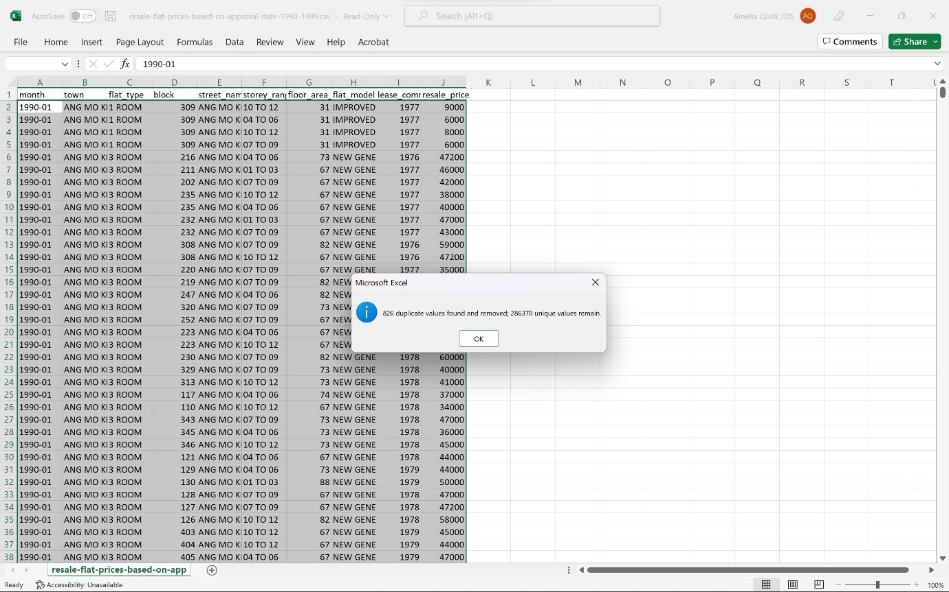 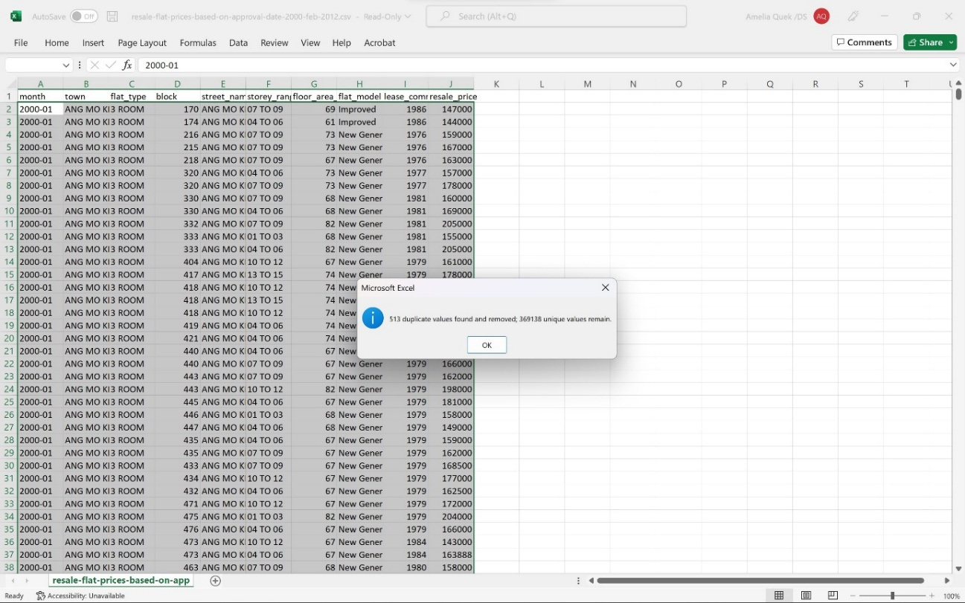 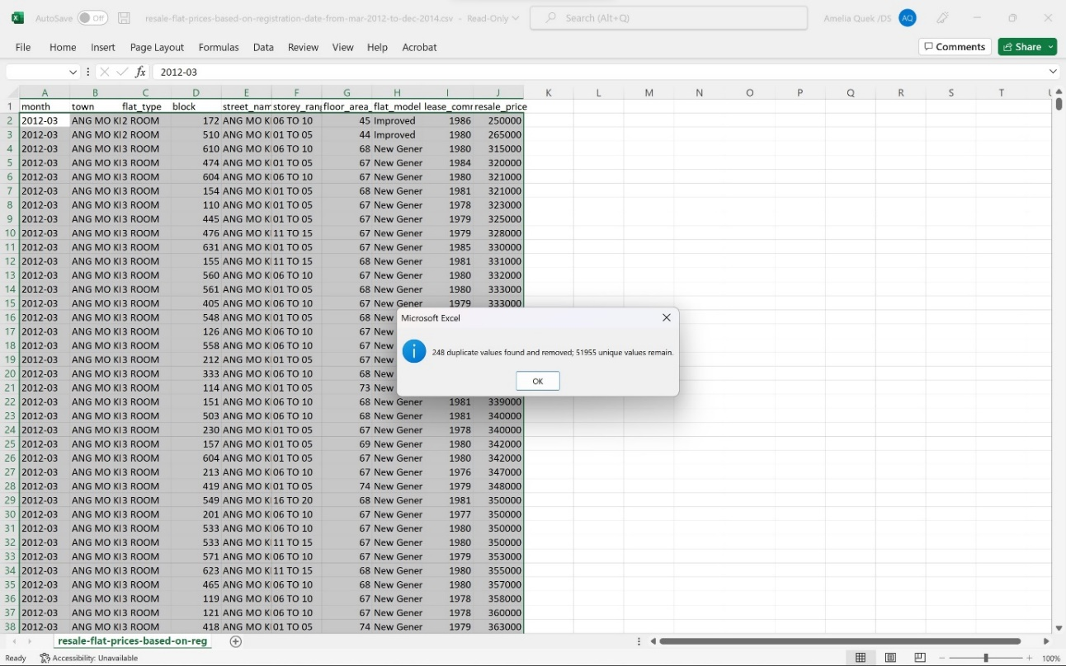 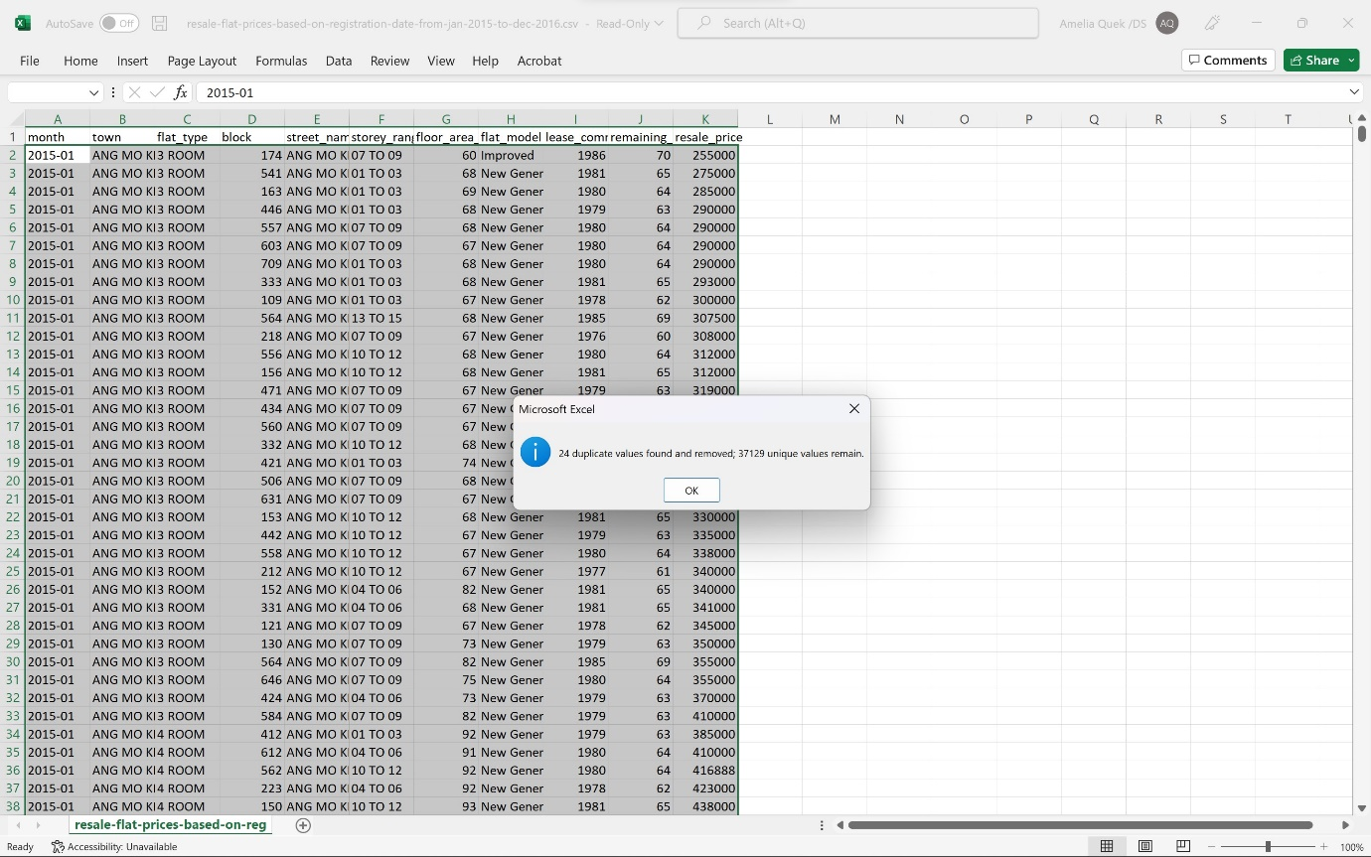

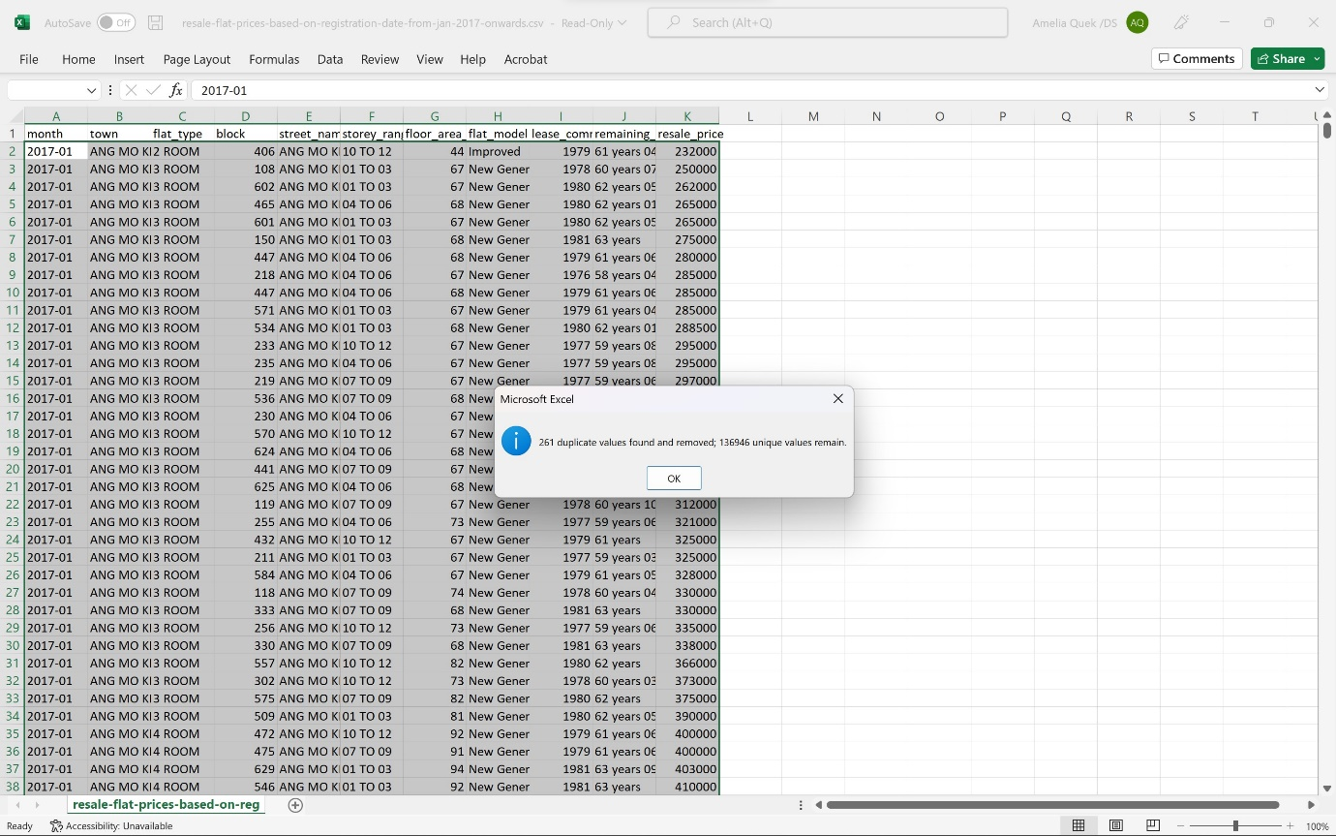

* Across the 5 datasets there were inconsistencies in the naming convention on flat model (‘improved’, ‘IMPROVED’)

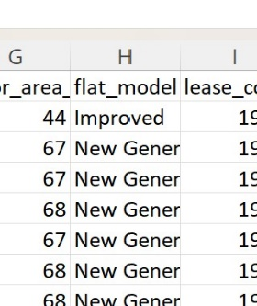 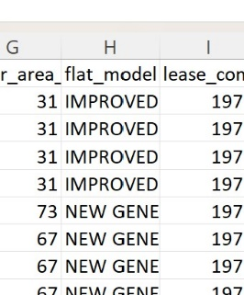

* Formatting for the resale price across the 5 data sets were inconsistent (‘$’, ‘S$’)

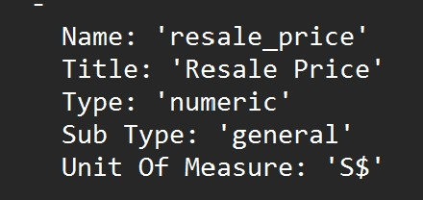 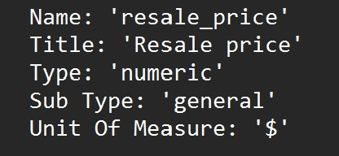

* Incomplete datasets (‘remaining lease’ field missing from 3 out of 5 data sets)

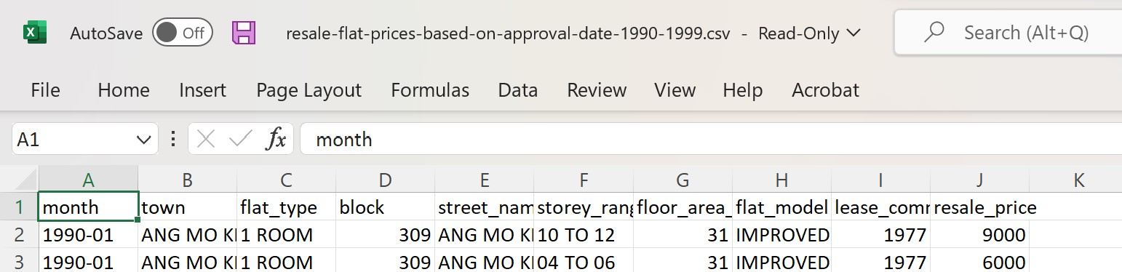

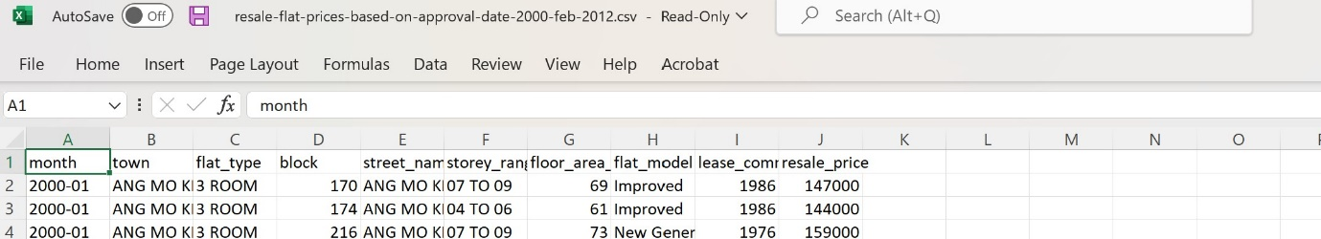

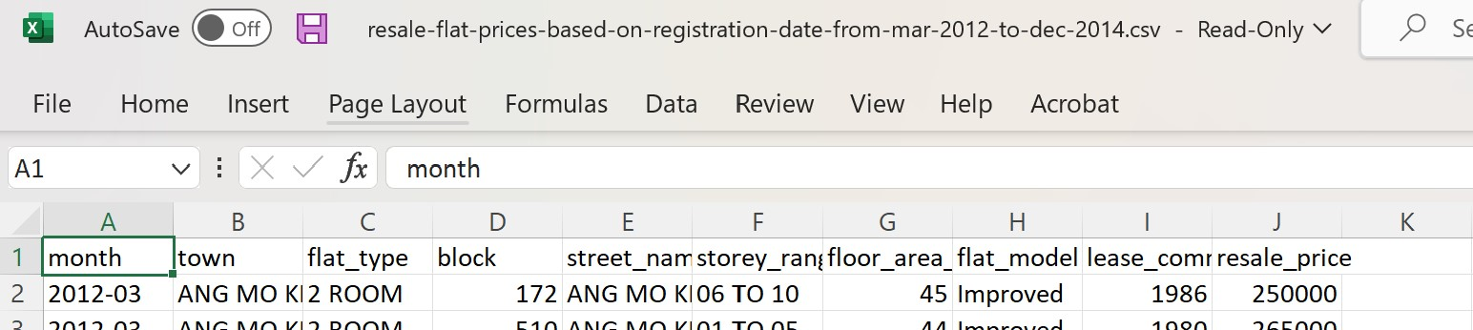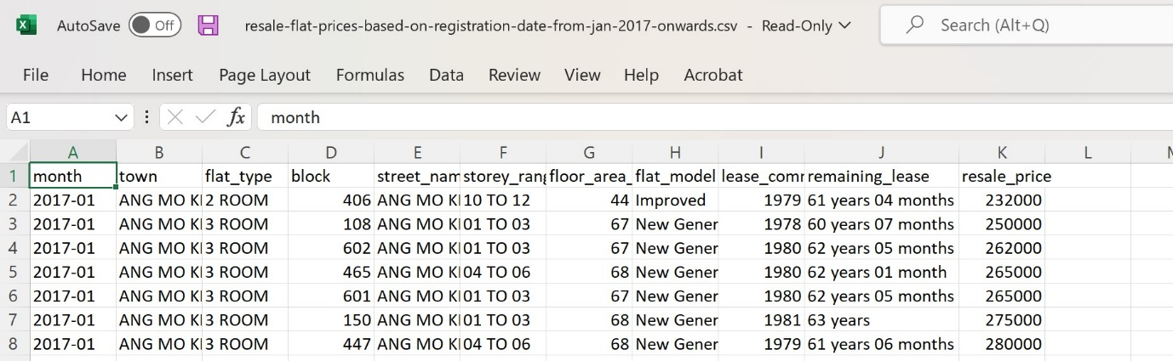

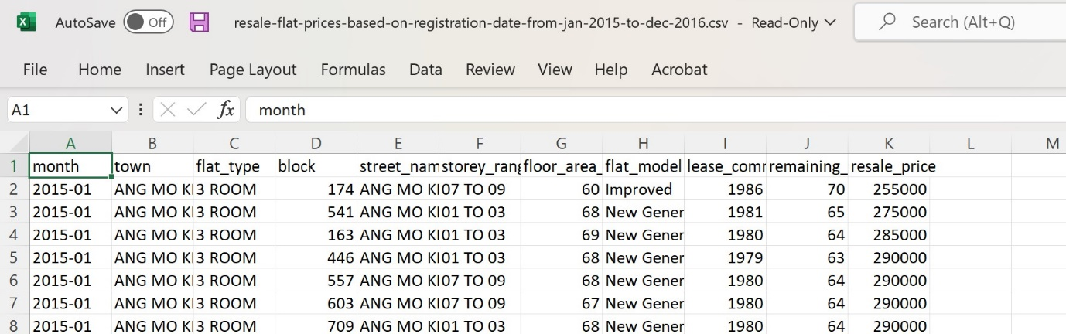

* Datasets containing the ‘remaining lease’ field differed in the level of detail (‘Years’, ’Years and Months’)

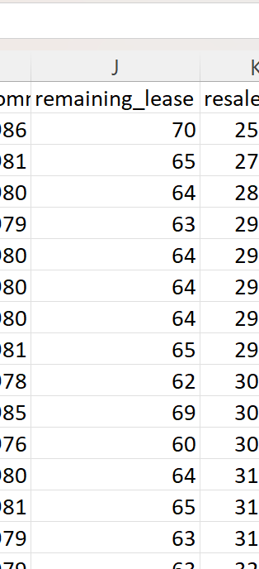 

* In the field “Flat type”, the naming of multi-generation flat type in the data set ‘resale-flat-prices-based-on-approval-date-1990-1999’ is missing a dash (-), i.e., ‘MULTI GENERATION’

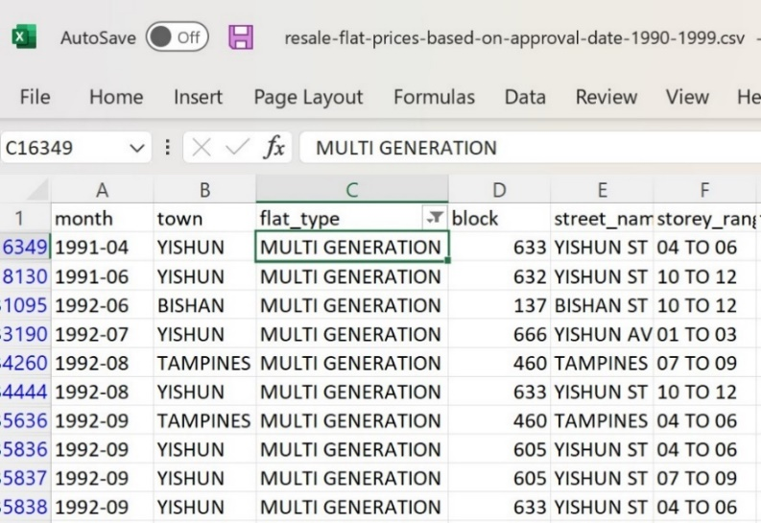 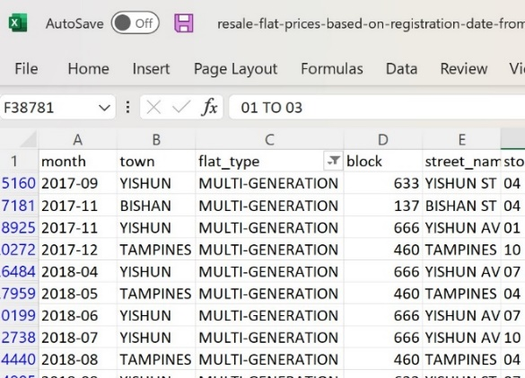

## Preparation of data

(How will you prepare your data to be suitable for exploration and analysis? Describe the steps involved in detail)

* + 1. Data cleansing

To clean my data to be able to consolidate it in tableau to analyse, I

* Removed the duplicates

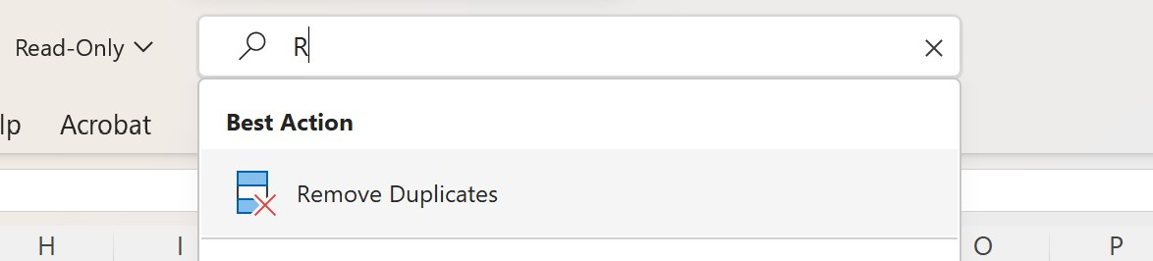

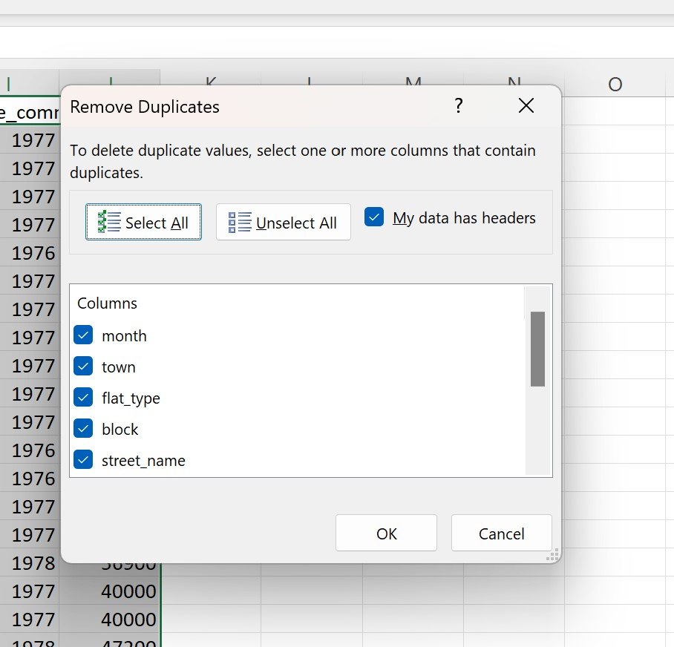

* Standardized the field ‘flat_model’ naming convention to be in all capital letters using the Formula =UPPER() across the 5 data sets

|  |
| --- |
| * 2-room → 2-ROOM |
| * 3Gen → 3GEN, |
| * Adjoined flat → ADJOINED FLAT, |
| * Apartment → APARTMENT, |
| * Improved → IMPROVED, |
| * Improved-Maisonette → IMPROVED-MAISONETTE, |
| * Maisonette → MAISONETTE, |
| * Model A → MODEL A, |
| * Model A2 → MODEL A2, |
| * Model A-Maisonette → MODEL A-MAISONETTE, |
| * Multi Generation → MULTI GENERATION, |
| * New Generation → NEW GENERATION, |
| * Premium Apartment → PREMIUM APARTMENT, |
| * Premium Apartment Loft → PREMIUM APARTMENT LOFT, |
| * Premium Maisonette → PREMIUM MAISONETTE, |
| * Simplified → SIMPLIFIED, |
| * Standard → STANDARD, |
| * Terrace → TERRACE, |
| * Type S1 → TYPE S1, |
| * Type S2 → TYPE S2 |

* Standardized the field ‘resale_price’ from ‘$’ to ‘S$’ across all the affected data sets

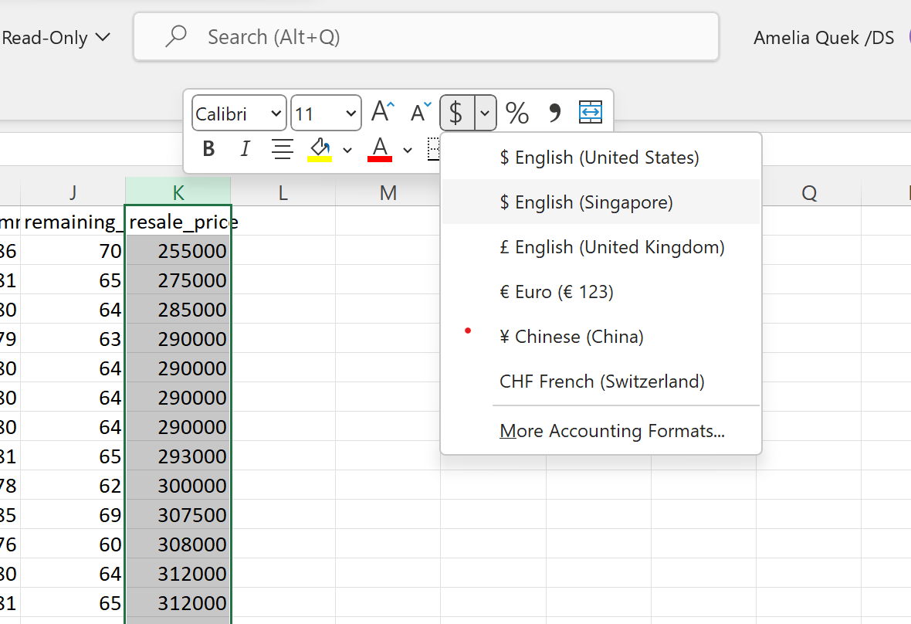

* Converted the affected data in the fields ‘remaining_lease’ format from years and months to years. By using the formula =LEFT(Cell,2) then I copied my reformatted years to row J1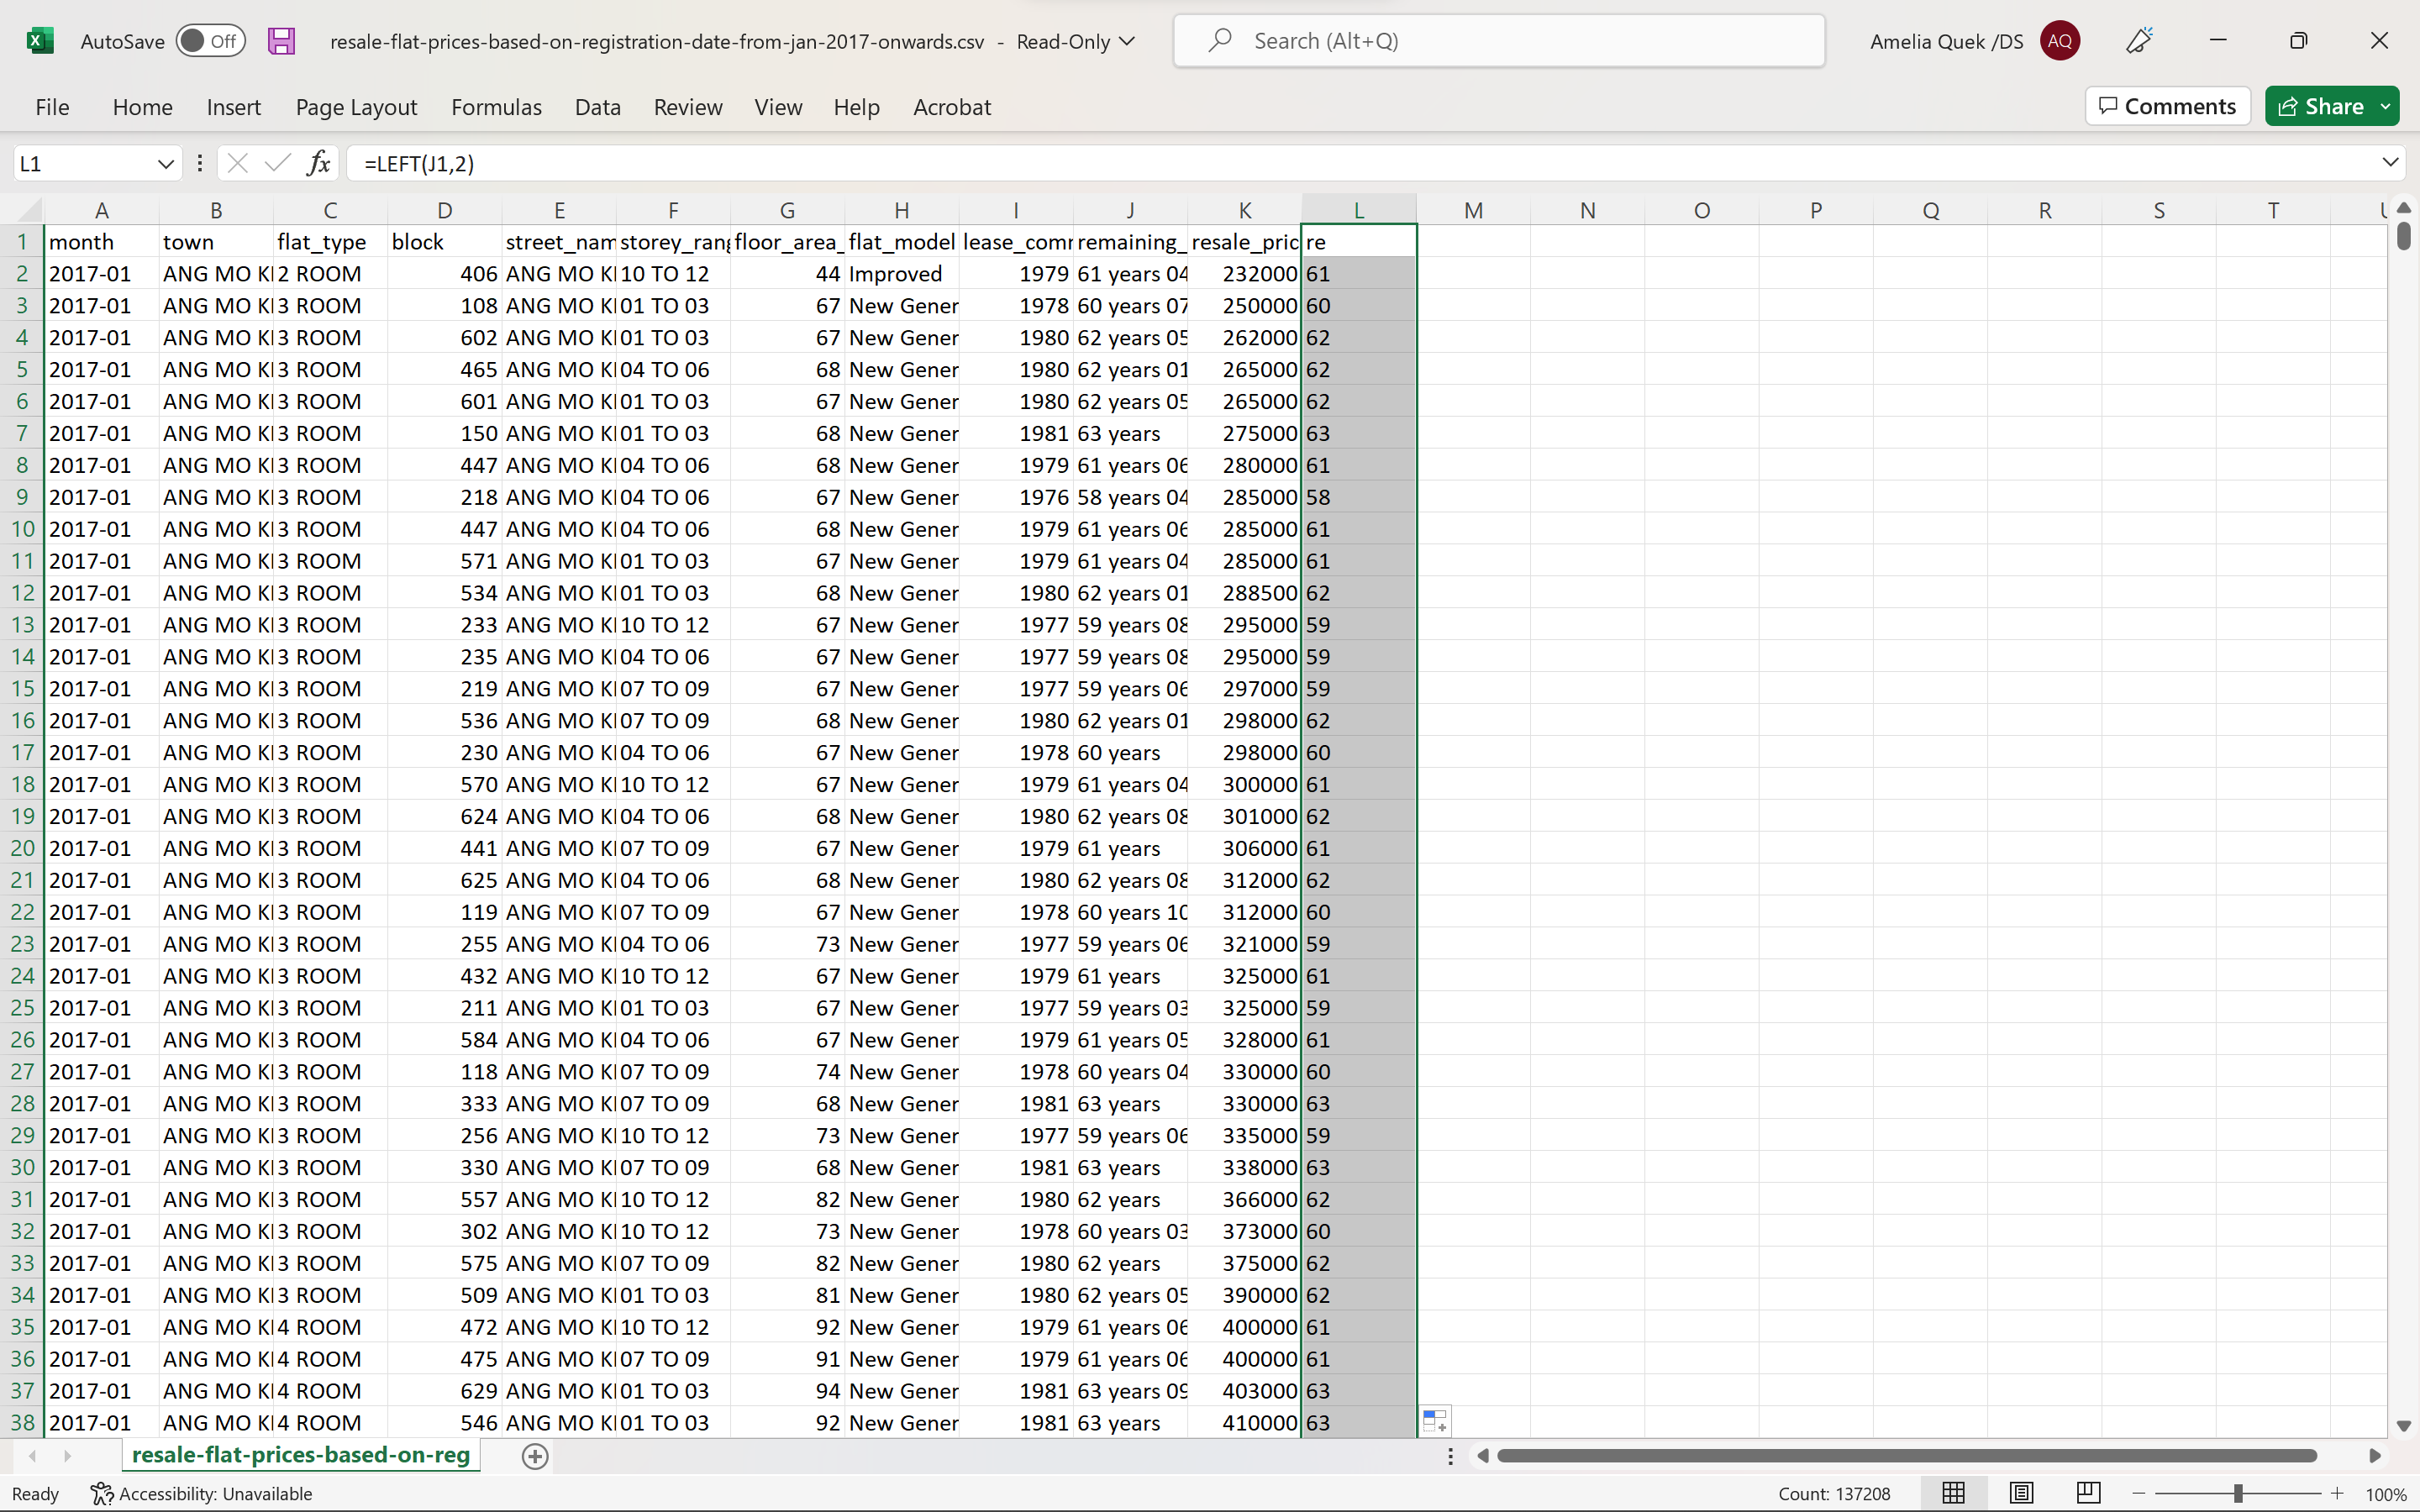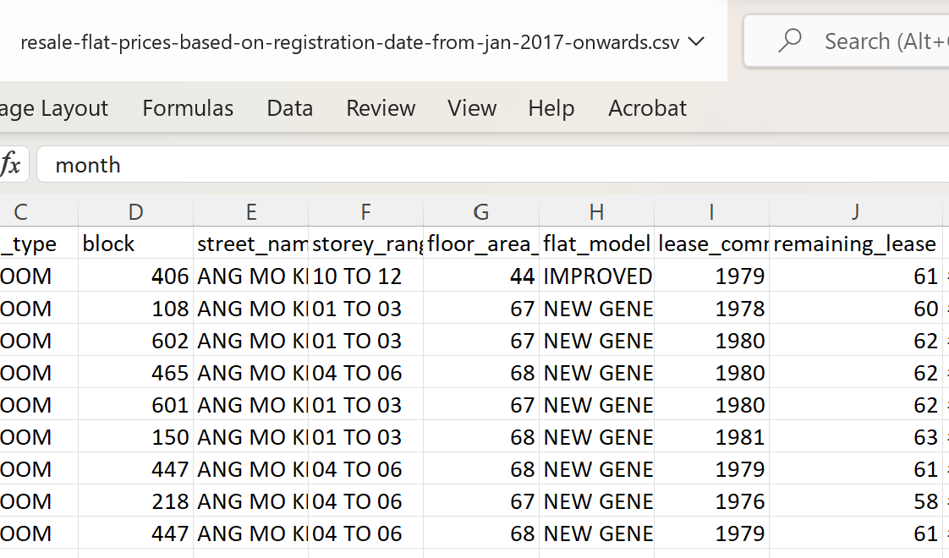
* First, I filtered my “flat_type” column to show “MULTI GENERATION”, then I used the formula =REPLACE to replace ‘MULTI GENERATION’ → ‘MULTI-GENERATION’ in data set ‘resale-flat-prices-based-on-approval-date-1990-1999’ field= “Flat type”.

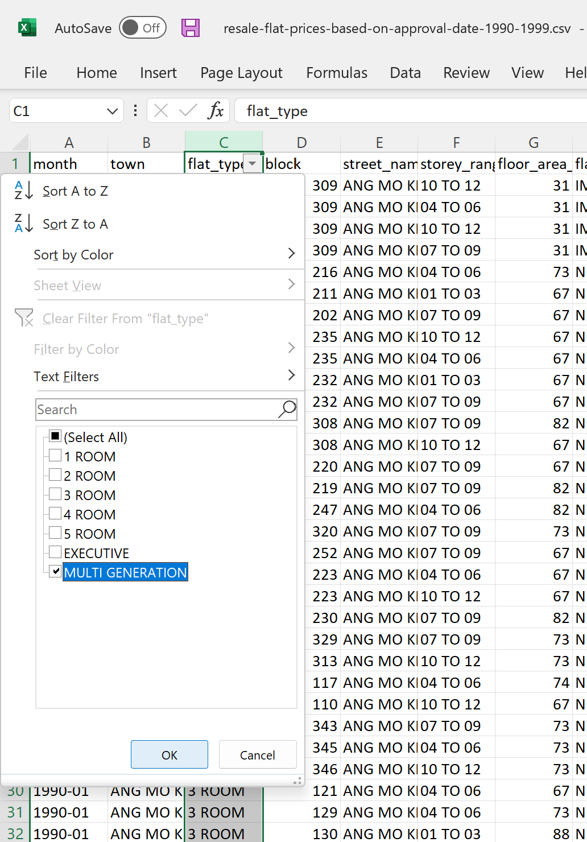 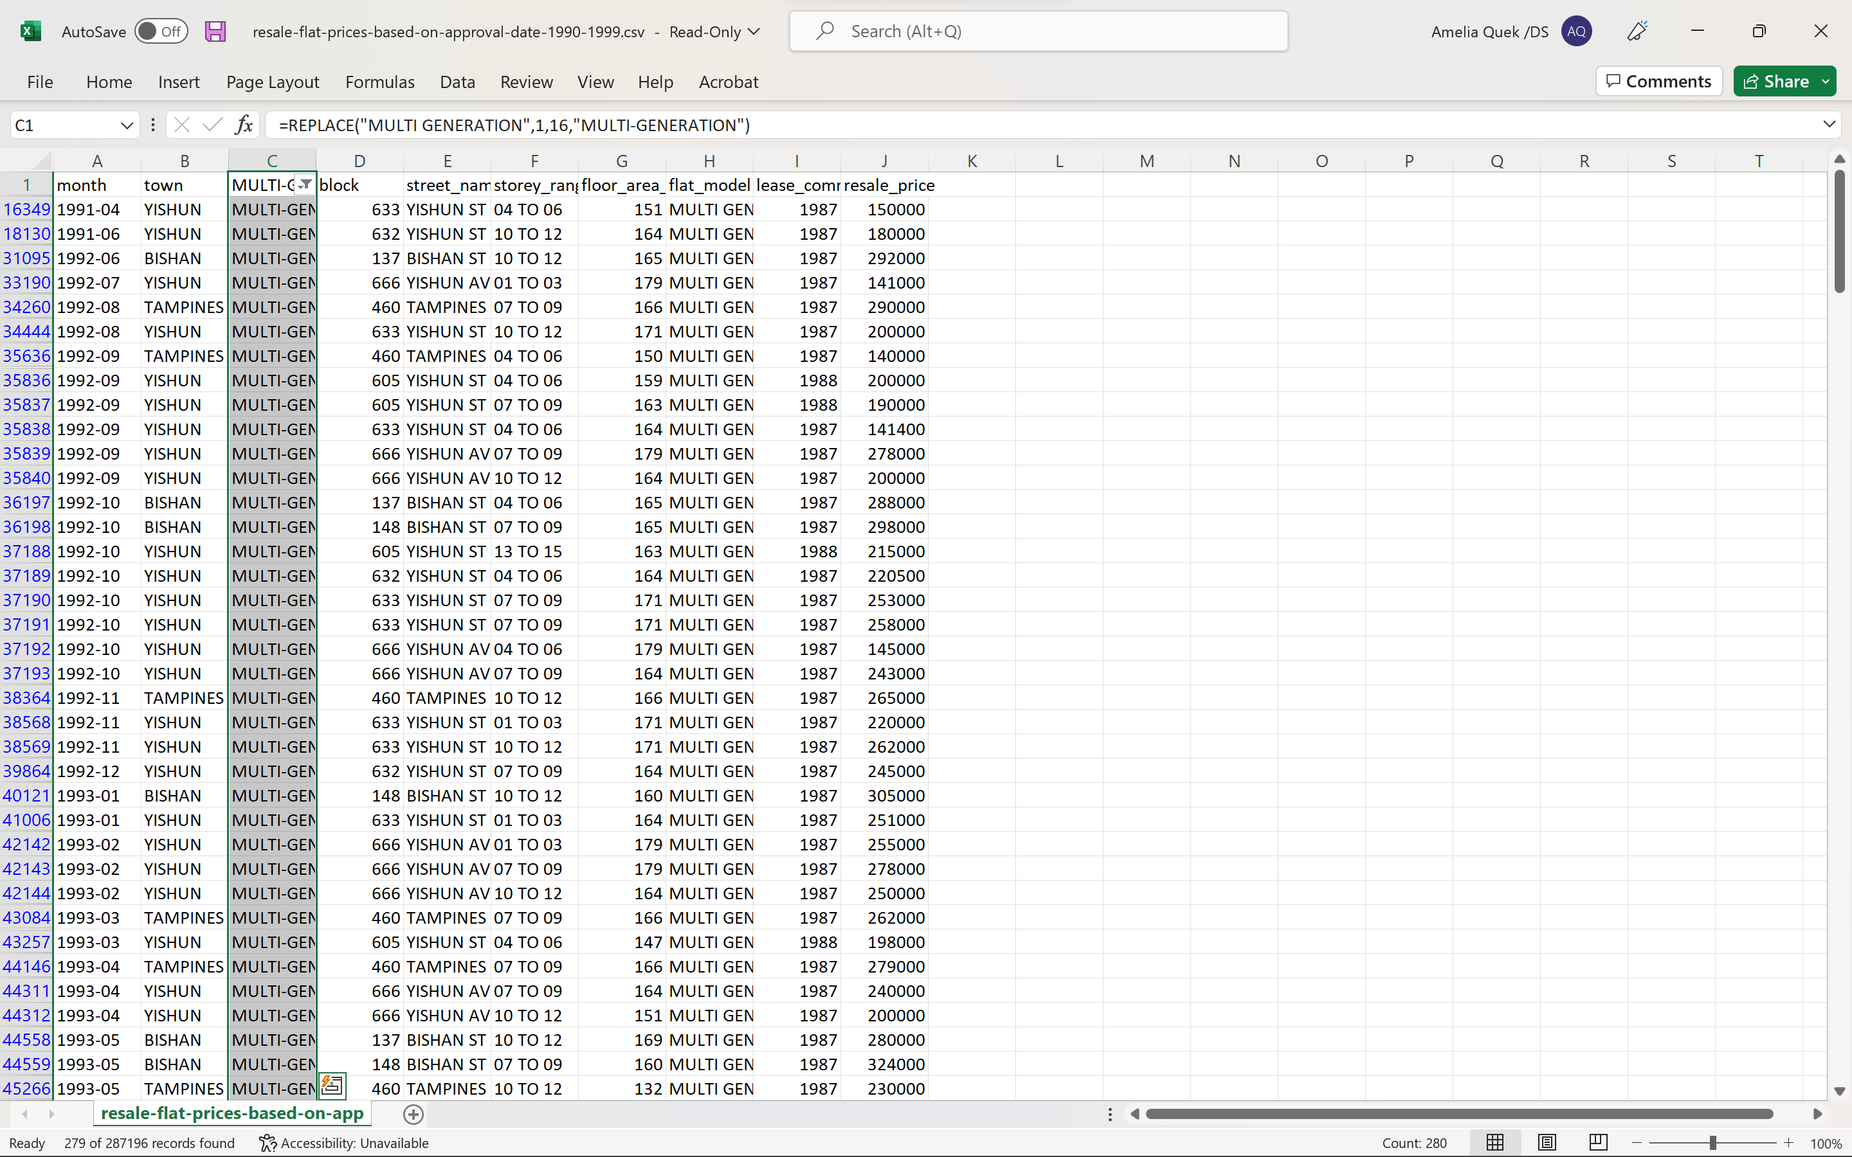 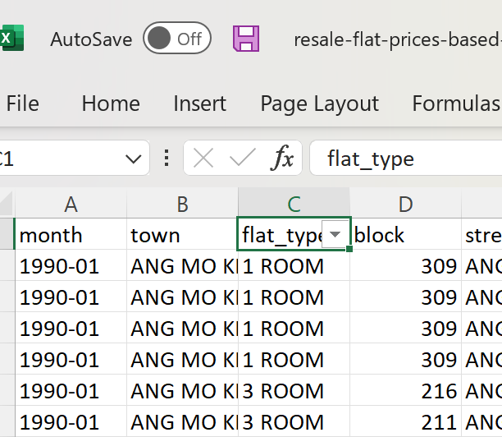

* + 1. Data consolidation

To consolidate my data in tableau, I first opened the file containing all my data sets given as well as an additional data set which includes the town name, latitude, and longitude of each town. I dragged the data sets given under the data set named ‘resale-flat-prices-based-on-approval-date-1990-1999’ thus making the dataset out of 6 tables I then made a full outer join between the resale flat data with the data set named 'Latitude and Longitude

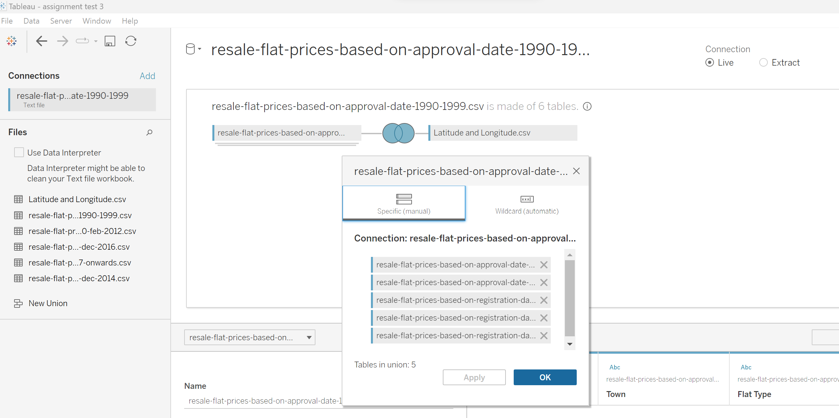

To further consolidate my data to better fit my stakeholders needs, I filtered out the data to select only the towns in the south and west of Singapore as well as 4-room flat types. Then, I right clicked on my filter and clicked ‘apply to worksheets’ and ‘all using this data source’. thus, filtering my filter across all my worksheets.

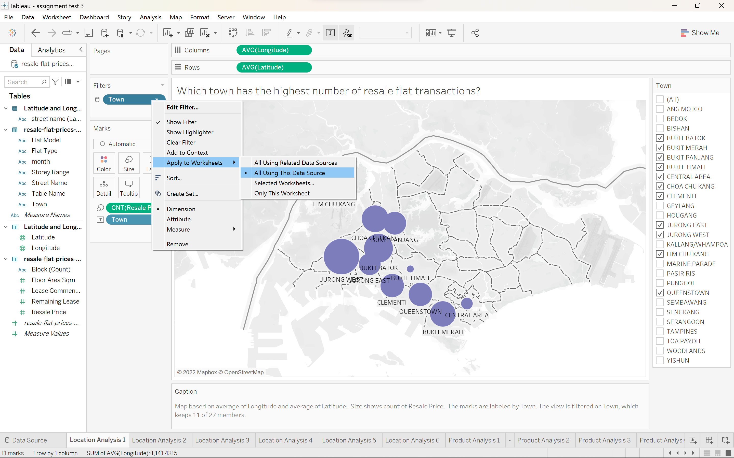

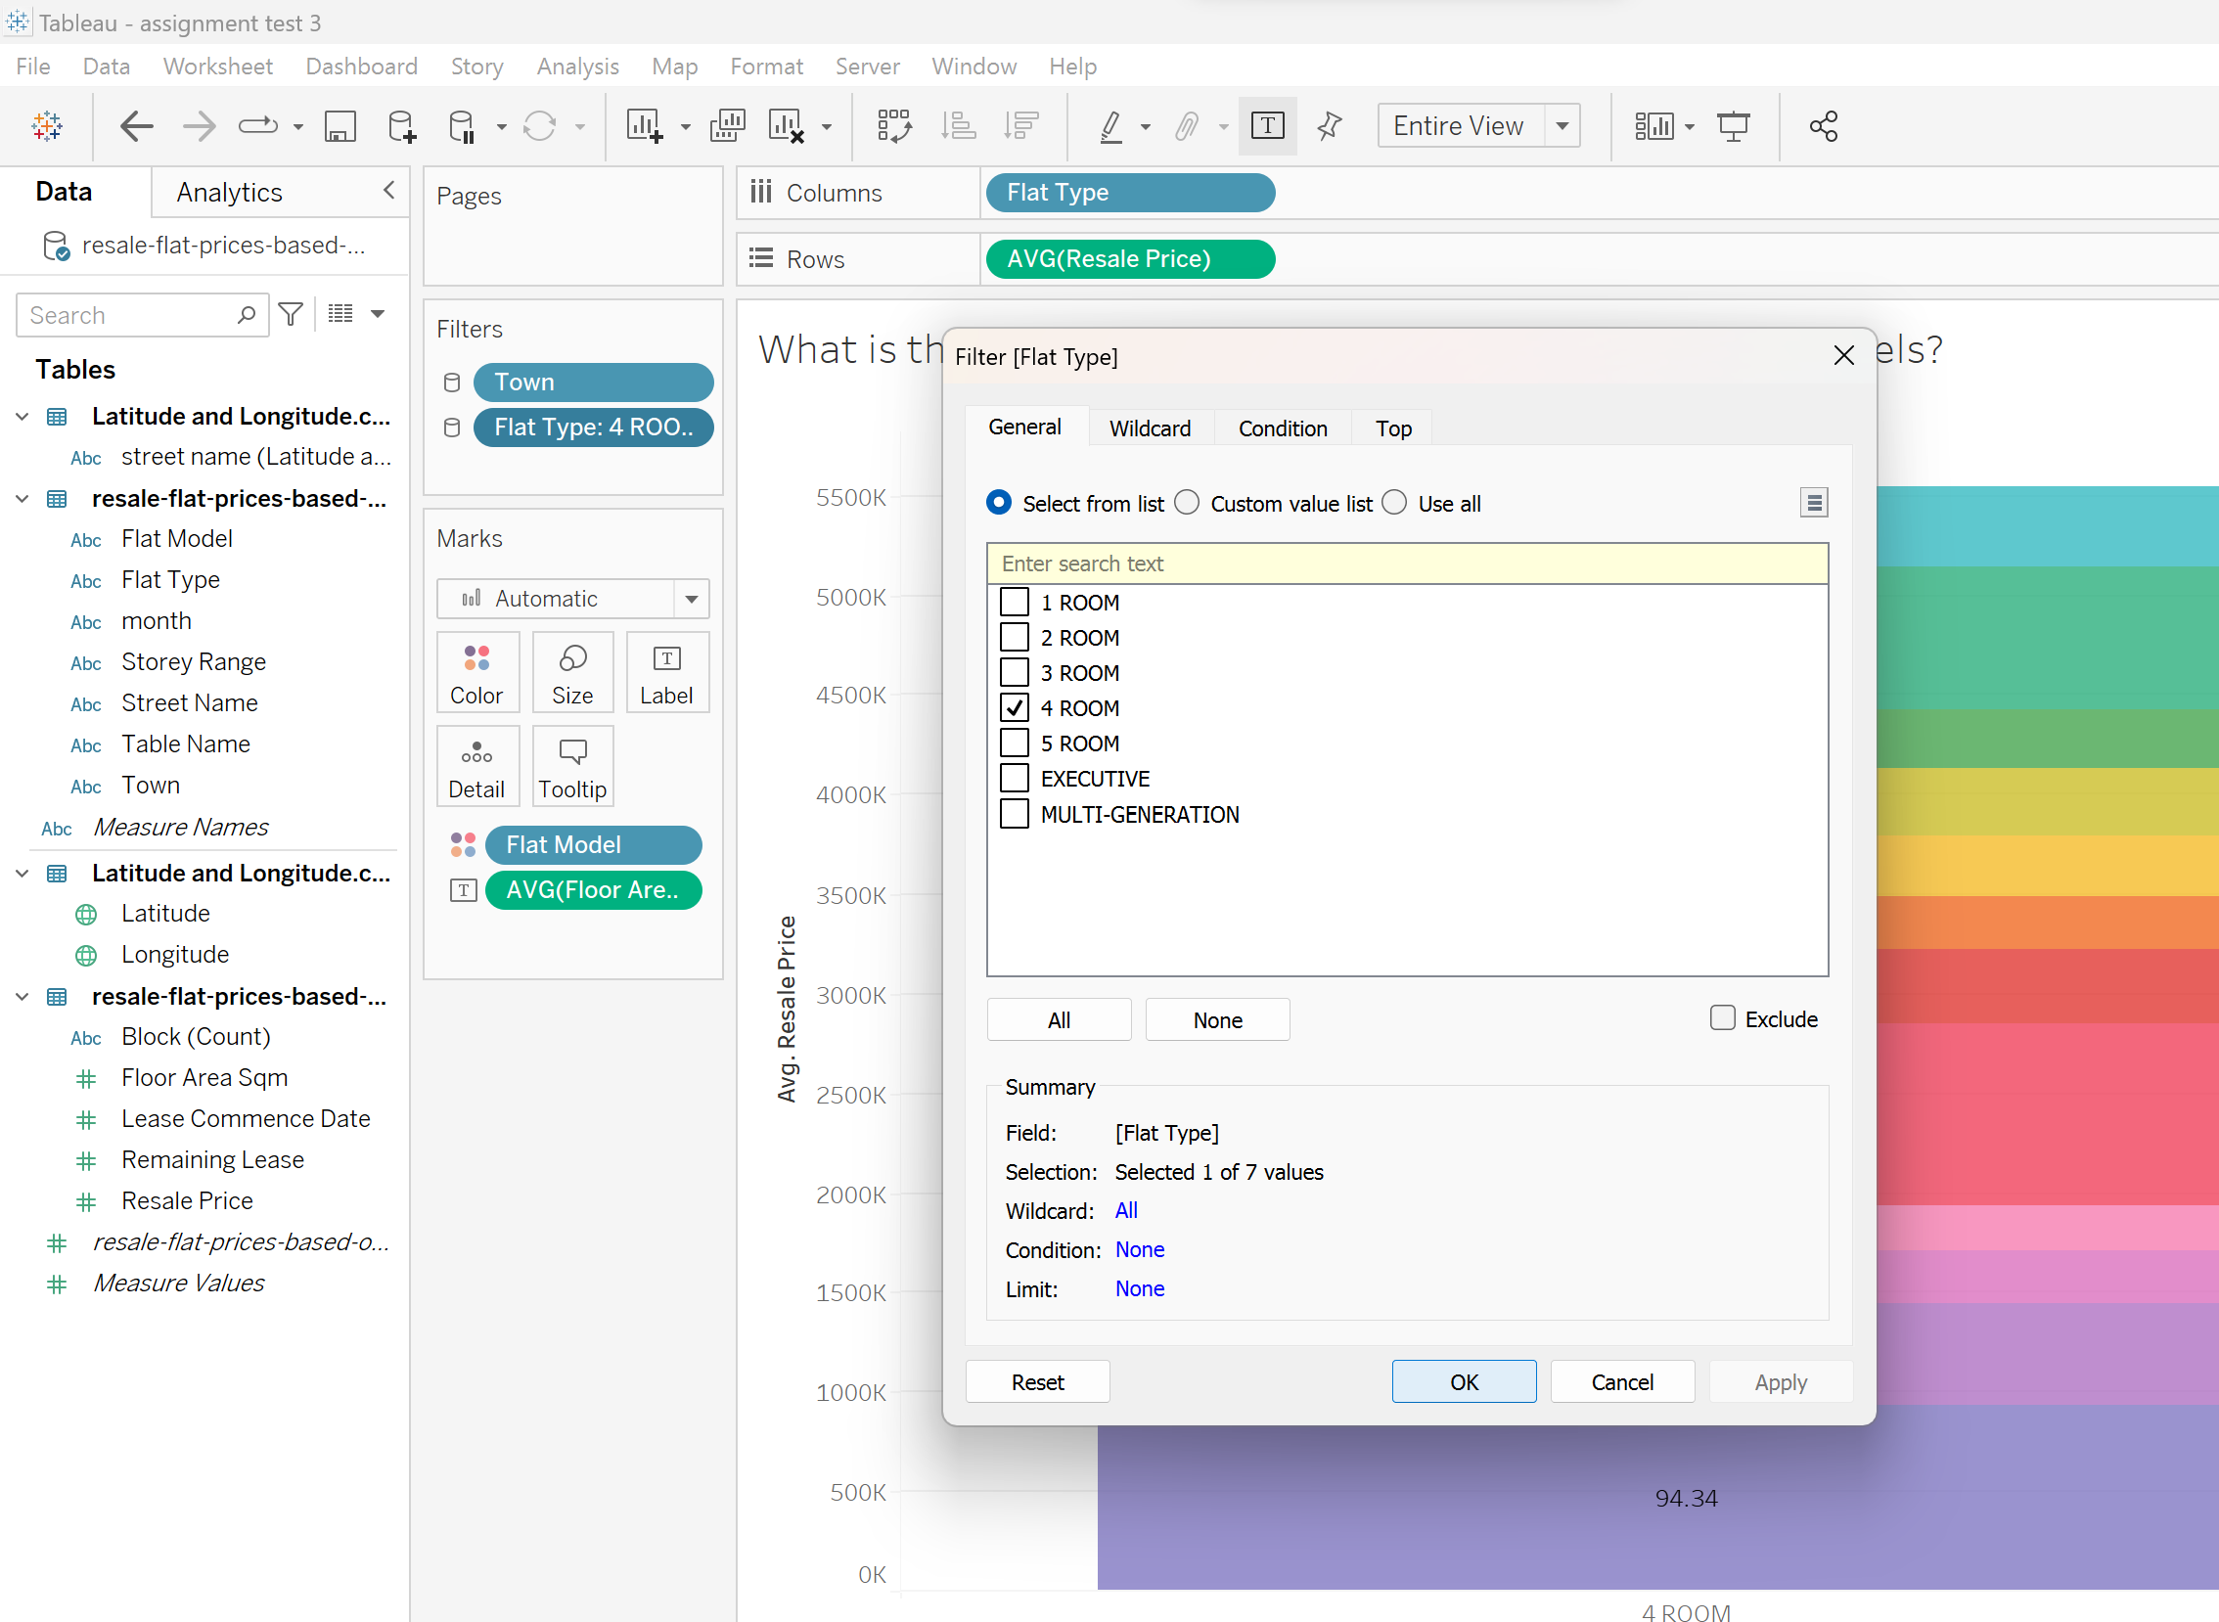

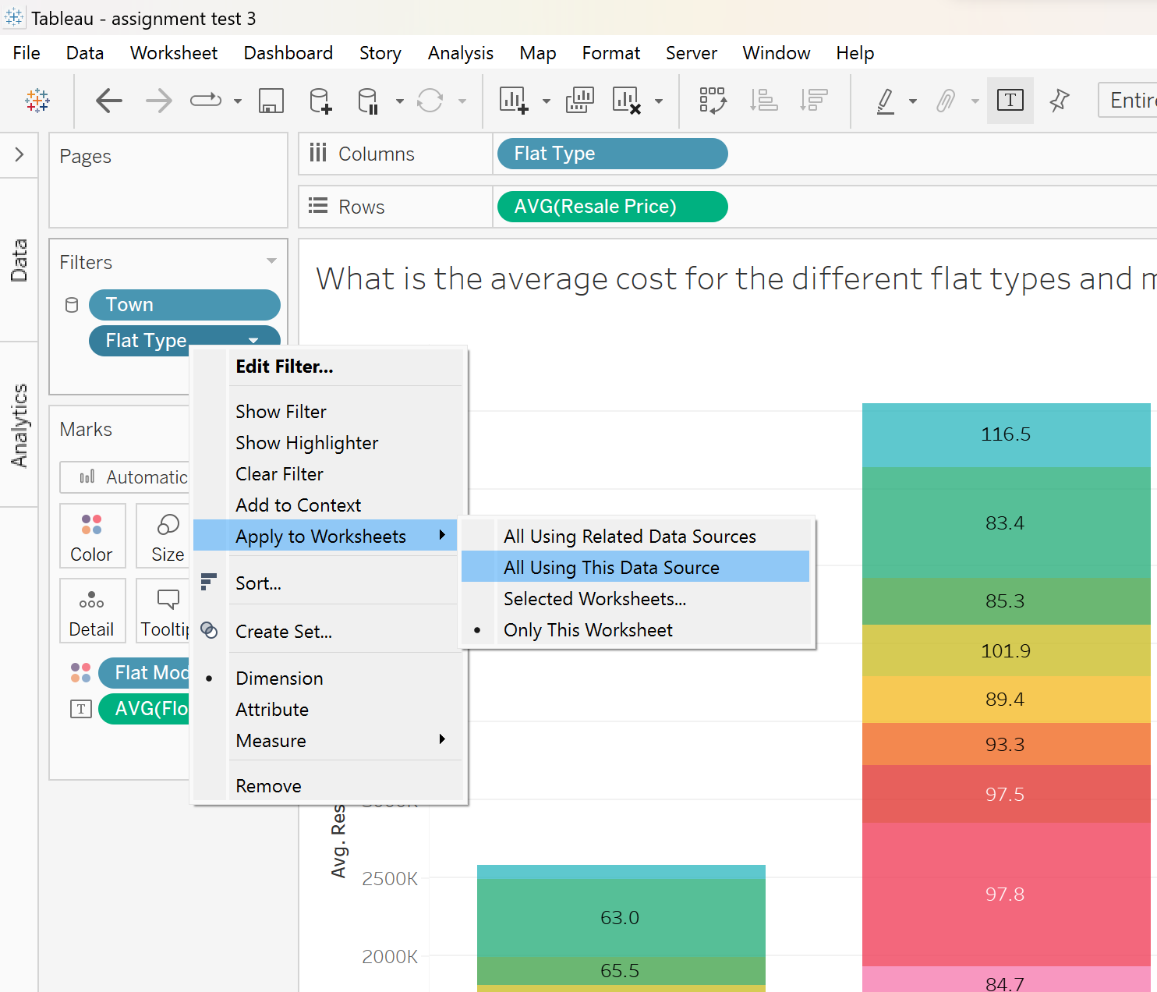

## Further research

(Did you perform further research to better understand the context of the data and metadata? Elaborate on the process and describe any additional findings)

To purchase a BTO flat, there are 5 main steps. First, check your eligibility as different flat types have different requirements. Next Balloting, which will take a month for you to be notified if your application was successful or not to choose which may take several chances you can also state your preferred location it will cost $10. Next checking your loan eligibility, followed by choosing your preferred flat type (4-room: $2000). Lastly signing your lease and paying for the actual flat (Poh, 2022). After a successful ballot, the average waiting time for your flat to be built is 4.1 years (Ho, 2022). Comparatively, a BTO is cheaper than a resale flat. However, resale flats tend to be bigger ((Ho, 2022). When looking to buy a BTO flat in a mature estate only 20 to 24 percent of first times applicants manage to get a flat due to the high demands for such prime locations (Ng, 2022). Additionally, If the stakeholder is buying a resale flat to live with or near their parents or child, they may apply for the Proximity Housing Grant (PHG): $30,000 to live with your parents/ child, $20,000 to live near your parents/ child (within 4km) (*HDB | Proximity Housing Grant (Families)*, n.d.).

# Exploratory Data Analysis and Visualization

## Visualization

(Identify the core findings and insights that help to answer the exploratory questions identified earlier. Create the visualizations accordingly. Describe each visualization by highlighting the exploratory questions it answers. Where necessary, explain how to interpret the visualizations in order to answer the exploratory questions (e.g., interactive elements).)

Location Analysis

1. Which town in the south and west of Singapore has the highest number of 4-room resale flats transactions?

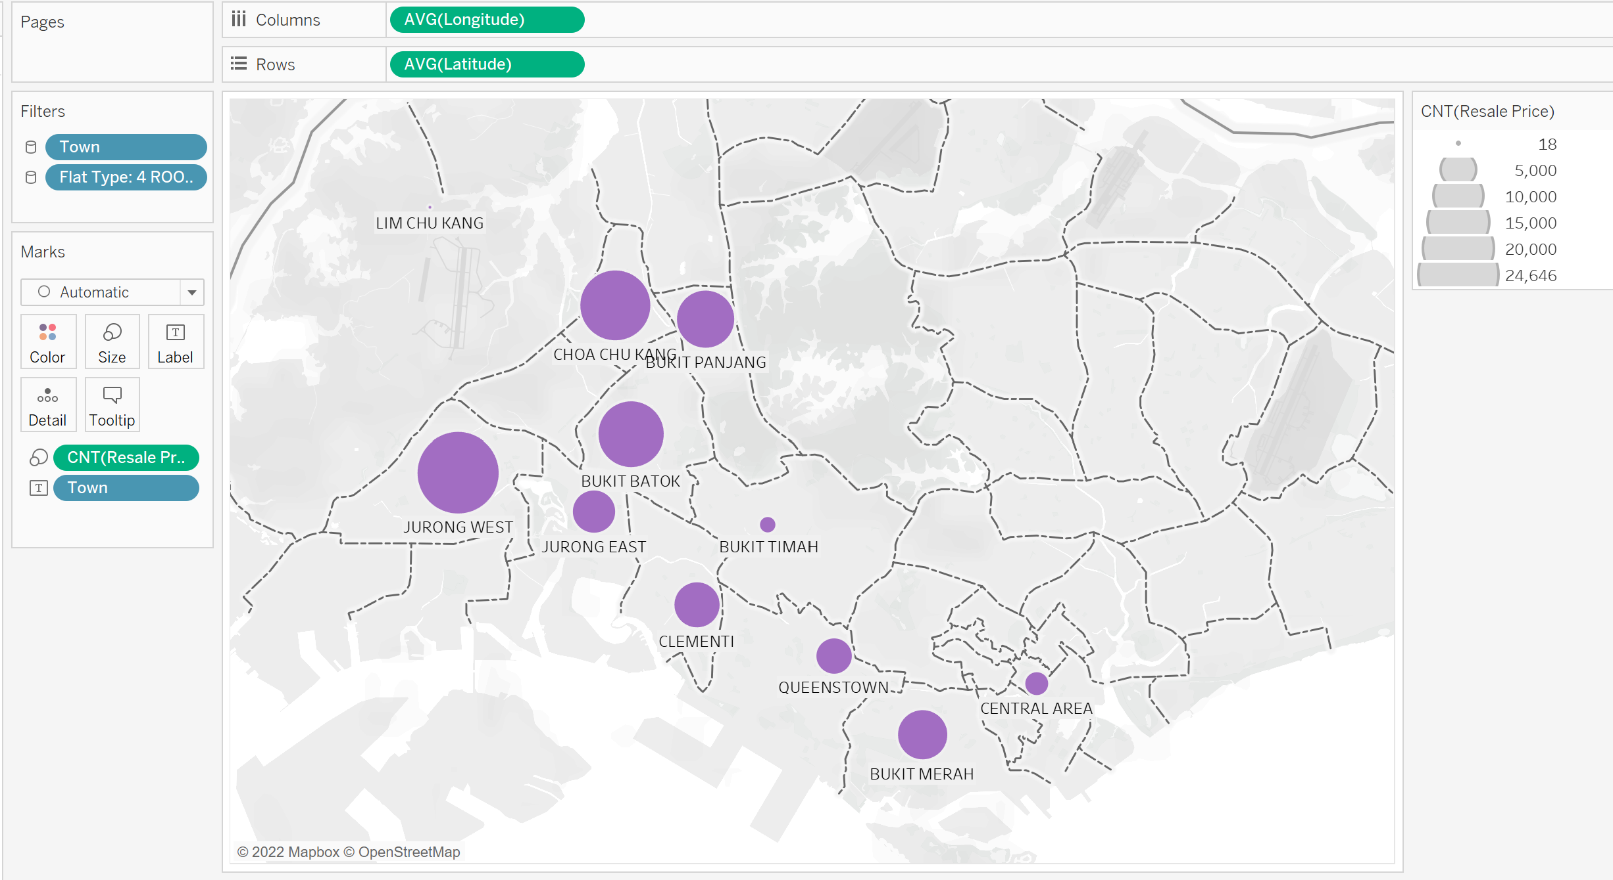

This visual shows a map of Singapore with circles of varying sizes which represent the number of resale flat transactions from the year 1990 to 2017 and onwards. With Jurong West having the highest number of resale flat transactions and Lim Chu Kang with the least. This visual highlight the supply of resale flats in the different towns, i.e. the bigger the circle the larger the supply.

(Map based on average of Longitude and average of Latitude. Size shows count of Resale Price. The marks are labeled by Town. The data is filtered on Flat Type, which keeps 4 ROOM. The view is filtered on Town, which keeps 11 of 27 members.)

1. What is the average resale price for a 4-room flat in its various towns in the south and west of Singapore?

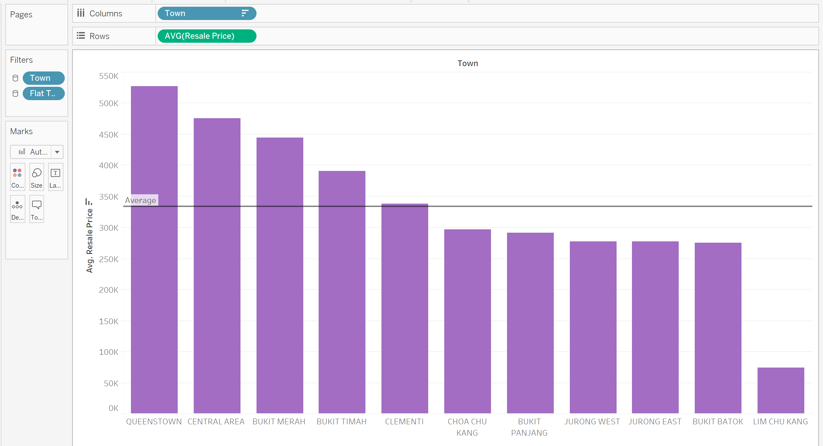

This visual shows the average resale price of each town arranged in descending order as well as an average line that shows the average resale price of all the towns. This visual shows that Queenstown has the highest average resale price for a flat and Lim Chu Kang has the lowest average resale price. Using this chart stakeholders can narrow down their town choices based on their budget.

(Average of Resale Price for each Town. The data is filtered on Flat Type, which keeps 4 ROOM. The view is filtered on Town, which keeps 11 of 27 members.)

1. Which towns in the south and west of Singapore have longer 4-room flat leases left?

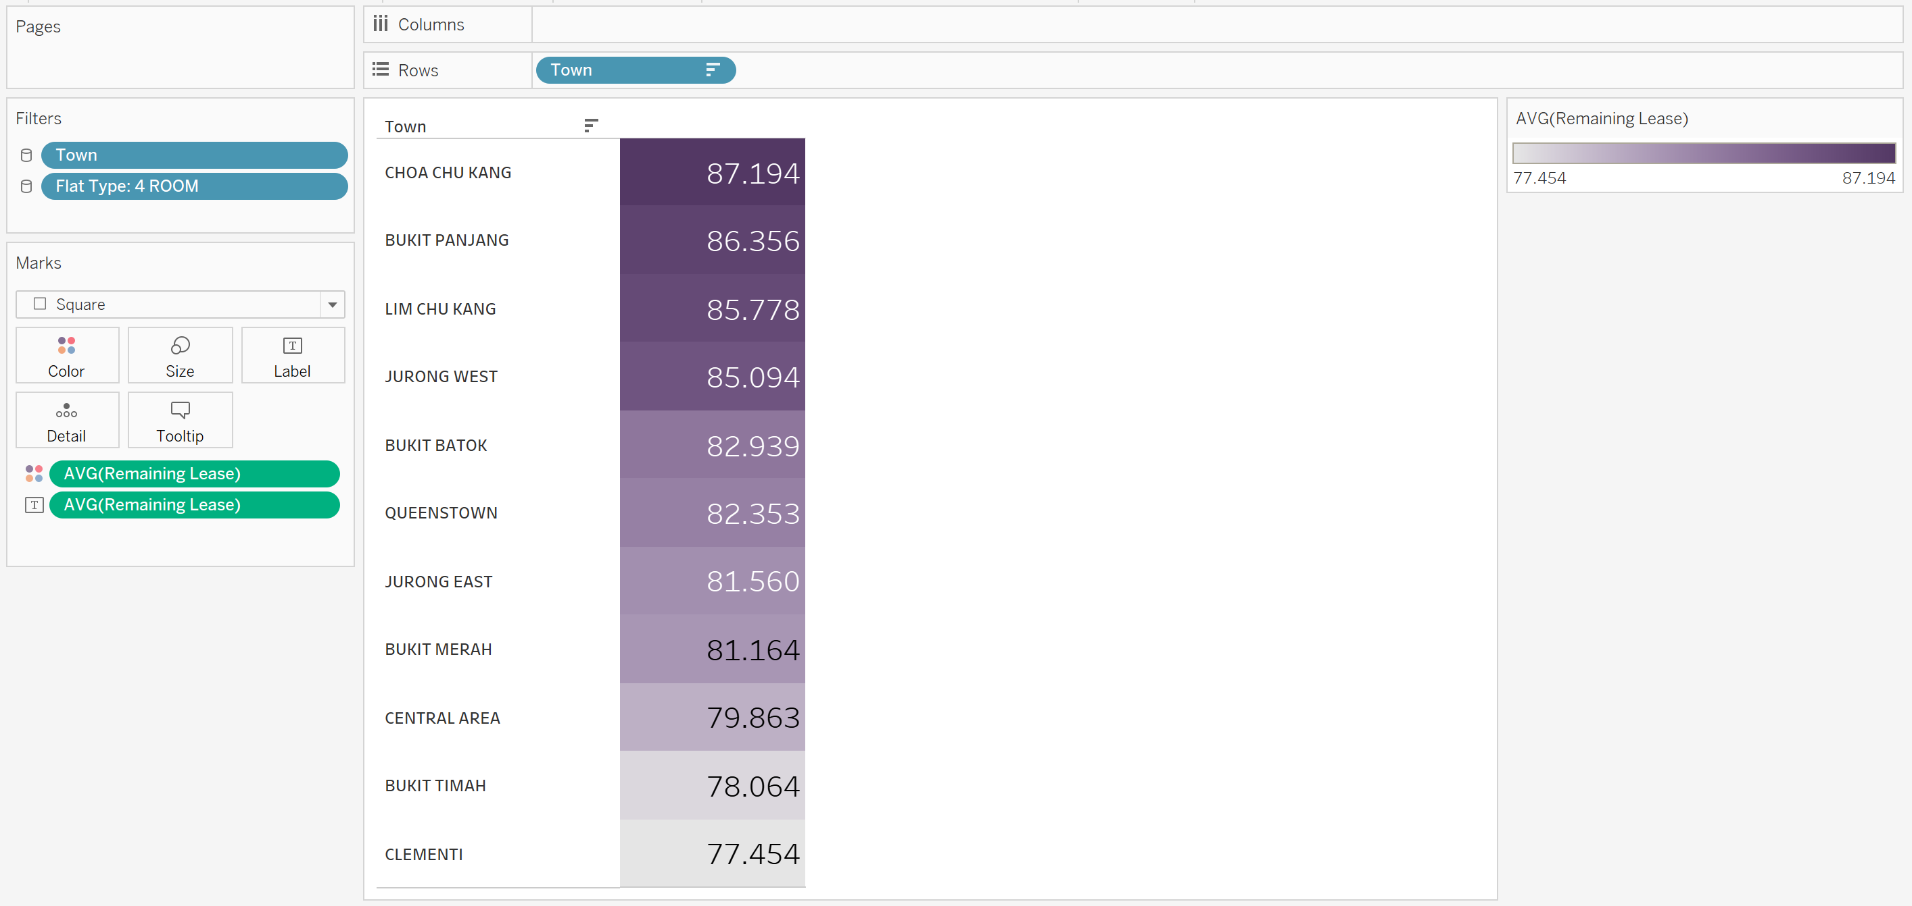

This visual shows me the average remaining lease broken down by the different towns arranged in descending order. This visual Chua Chu Kang has the longest average remaining lease left and Clementi has the shortest remaining lease left. Using this visual, the stakeholders can identify the towns with longer leases.

(Average of Remaining Lease broken down by Town. Color shows average of Remaining Lease. The marks are labeled by average of Remaining Lease. The data is filtered on Flat Type, which keeps 4 ROOM. The view is filtered on Town, which keeps 11 of 27 members.)

1. What are the sizes of the different 4-room flat models available in the various towns in the south and west of Singapore?

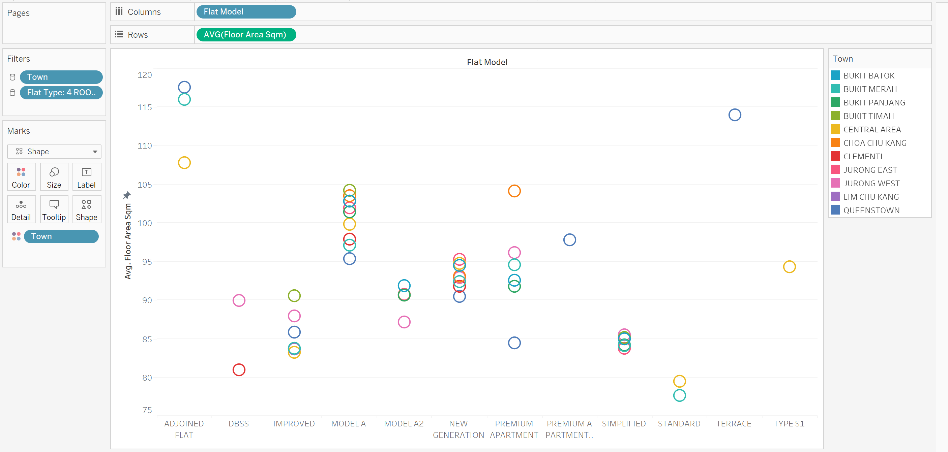

This visual shows the average Floor Area Sqm of the different 4 room flat models in the different towns. For each flat model, the colour of the circles represents the availability of the flat model in the different towns and the position of the circle shows the average Floor Area Sqm of the flats in these towns. This chart show stakeholders the size of the different flat model types across various towns.

(Average of Floor Area Sqm for each Flat Model. Color shows details about Town. The data is filtered on Flat Type, which keeps 4 ROOM. The view is filtered on Town, which keeps 11 of 27 members.)

1. Which towns in the south and west of Singapore have more 4-room flats above the 20th floor?

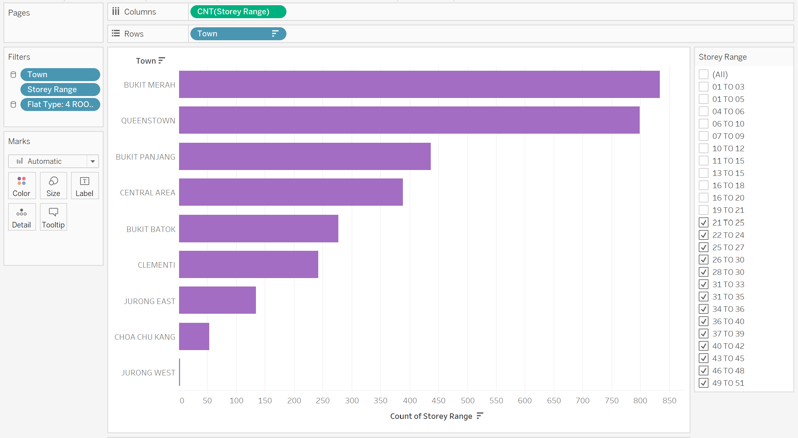

This visual shows the number of 4-room flats above the twentieth floor in descending order. This visual shows that Bukit Merah has the highest number of flats that are above the 20th floor and Jurong West has the lowest number of flats that are above the 20th floor. And towns Bukit Timah and Lim Chu Kang are not shown in the visual as they do not have 4-room flats above the 20th floor. This helps the stakeholders to identify or shortlist their preferred location based on the availability of high-rise flats.

(Count of Storey Range for each Town. The data is filtered on Storey Range and Flat Type. The Storey Range filter keeps 14 of 25 members. The Flat Type filter keeps 4 ROOM. The view is filtered on Town, which keeps 11 of 27 members.)

Product Analysis

1. What are the resale prices and average remaining leases for the various 4-room flat models in the south and west of Singapore?

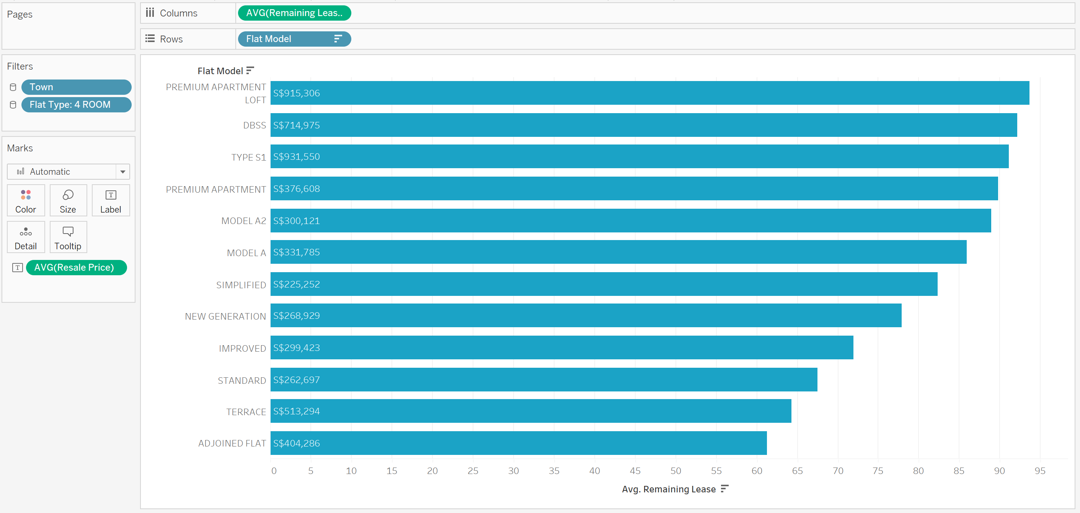

This visual shows the average remaining lease and resale price of the different 4 room flat types in descending order of remaining lease. From this visual, stakeholders can decide if they are looking to prioritise their choices based of the remaining lease or price. (e.g. PREMIUM APARTMENT LOFT has the longest lease but highest price, whereas ADJOINED FLAT has a cheaper price but has the shortest lease)

(Average of Remaining Lease for each Flat Model. The data is filtered on Town and Flat Type. The Town filter keeps 11 of 27 members. The Flat Type filter keeps 4 ROOM.)

1. How many 4-room flats of each model have been re-sold in the south and west of Singapore?

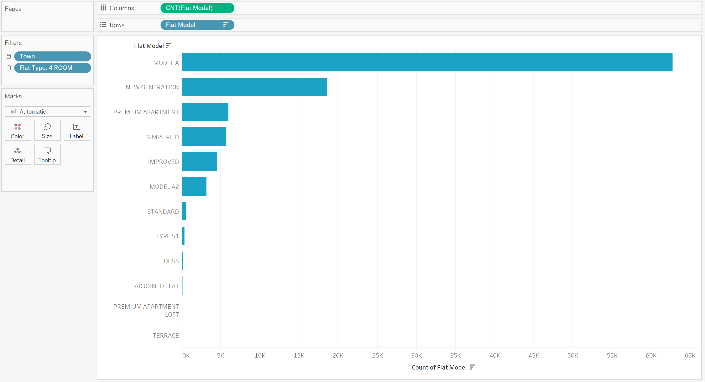

This visual shows the number of resale flats sold for each 4-room flat model. This visual show that the flat model with the highest no of resale flats sold is MODEL A and the lowest being TERRACE. From this, the stakeholders can identify the flat model that has a higher supply in the market.

(Count of Flat Model for each Flat Model. The data is filtered on Town and Flat Type. The Town filter keeps 11 of 27 members. The Flat Type filter keeps 4 ROOM.)

1. What is the average size of the different 4-room flat models in the south and west of Singapore?

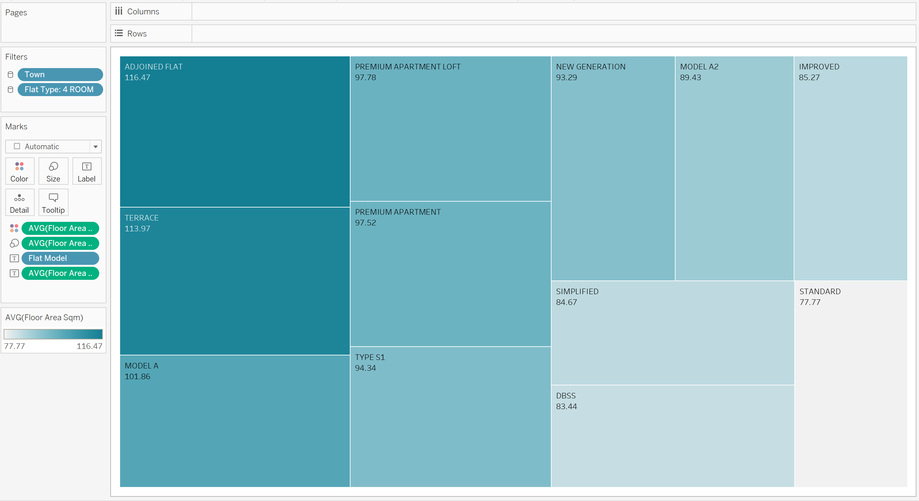

This visual shows the average Floor area Sqm of the different 4-room flat models. This visual shows the largest flat model is ADJOINED FLAT and the smallest is STANDARD. From this, the stakeholder can see the average size of the different model types and make a selection based on the flat size they require.

(Flat Model and average of Floor Area Sqm. Color shows average of Floor Area Sqm. Size shows average of Floor Area Sqm. The marks are labeled by Flat Model and average of Floor Area Sqm. The data is filtered on Town and Flat Type. The Town filter keeps 11 of 27 members. The Flat Type filter keeps 4 ROOM.)

1. What are the 4-room flat models in the south and west of Singapore with higher floor ranges?

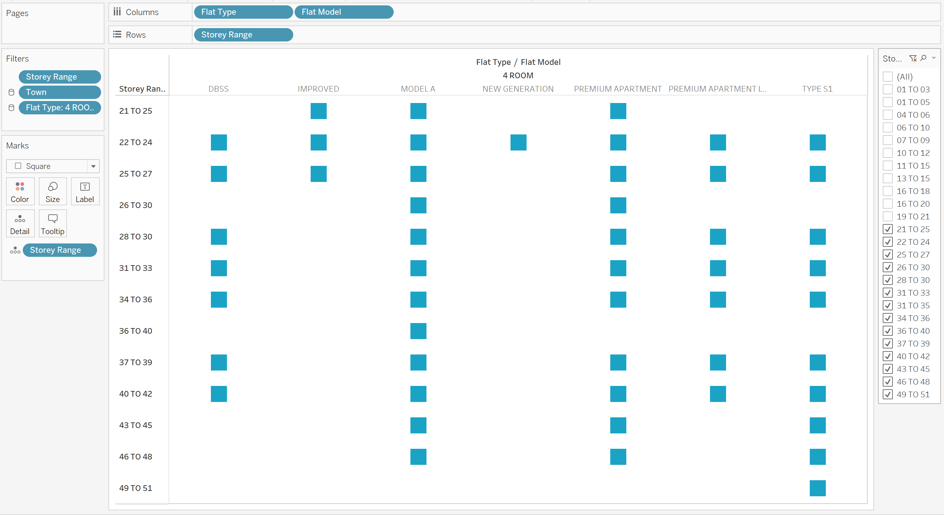

This visual shows the different flat models types that are above the 20th floor. This visual shows that Flat Model “MODEL A” has the most floor ranges available and NEW GENERATION has the least. Flat Model’s … do not have any flats within the floor ranges above the 20th floor. From this, the stakeholders can reduce their flat model selection to the number of high rise flats available.

(The view is broken down by Flat Type and Flat Model vs. Storey Range. Details are shown for Storey Range. The data is filtered on Town, which keeps 11 of 27 members. The view is filtered on Storey Range and Flat Type. The Storey Range filter keeps 14 of 25 members. The Flat Type filter keeps 4 ROOM.)

Price Analysis

1. What is the average resale price trend of 4-room flats over the years in the south and west of Singapore?

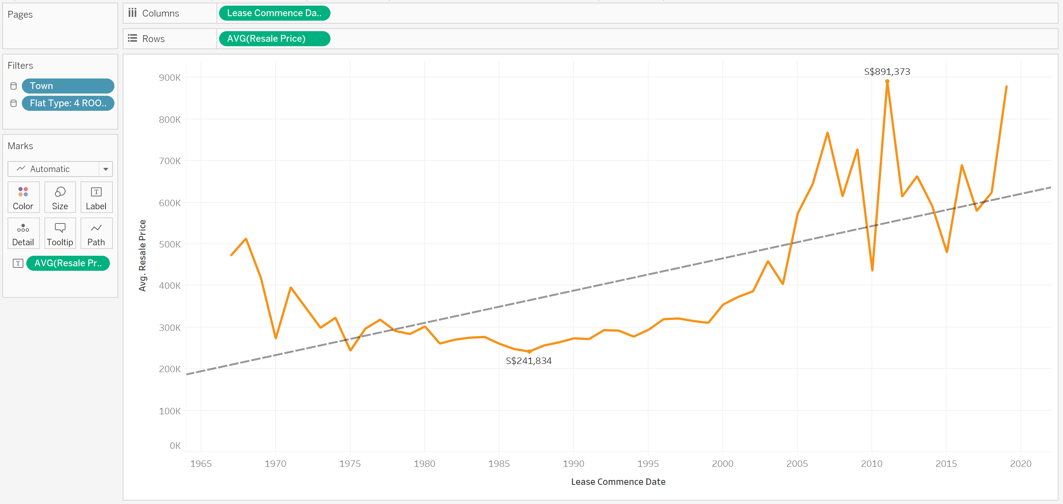

This visual shows the trend of average resale prices of each year over the years. Year 2011 has the highest average resale price of $891 373 and Year 1975 has the lowest with an average resale price of $244 165. There is an increase in the overall average resale price trend over the years as shown in the visual. From this, the stakeholders can see that resale flat prices are increasing.

(The trend of average of Resale Price for Lease Commence Date. The marks are labeled by average of Resale Price. The data is filtered on Town and Flat Type. The Town filter keeps 11 of 27 members. The Flat Type filter keeps 4 ROOM.)

1. What is the trend for the average Floor Area Sqm and the average Resale Price over the years for a 4-room flat in the south and west of Singapore?

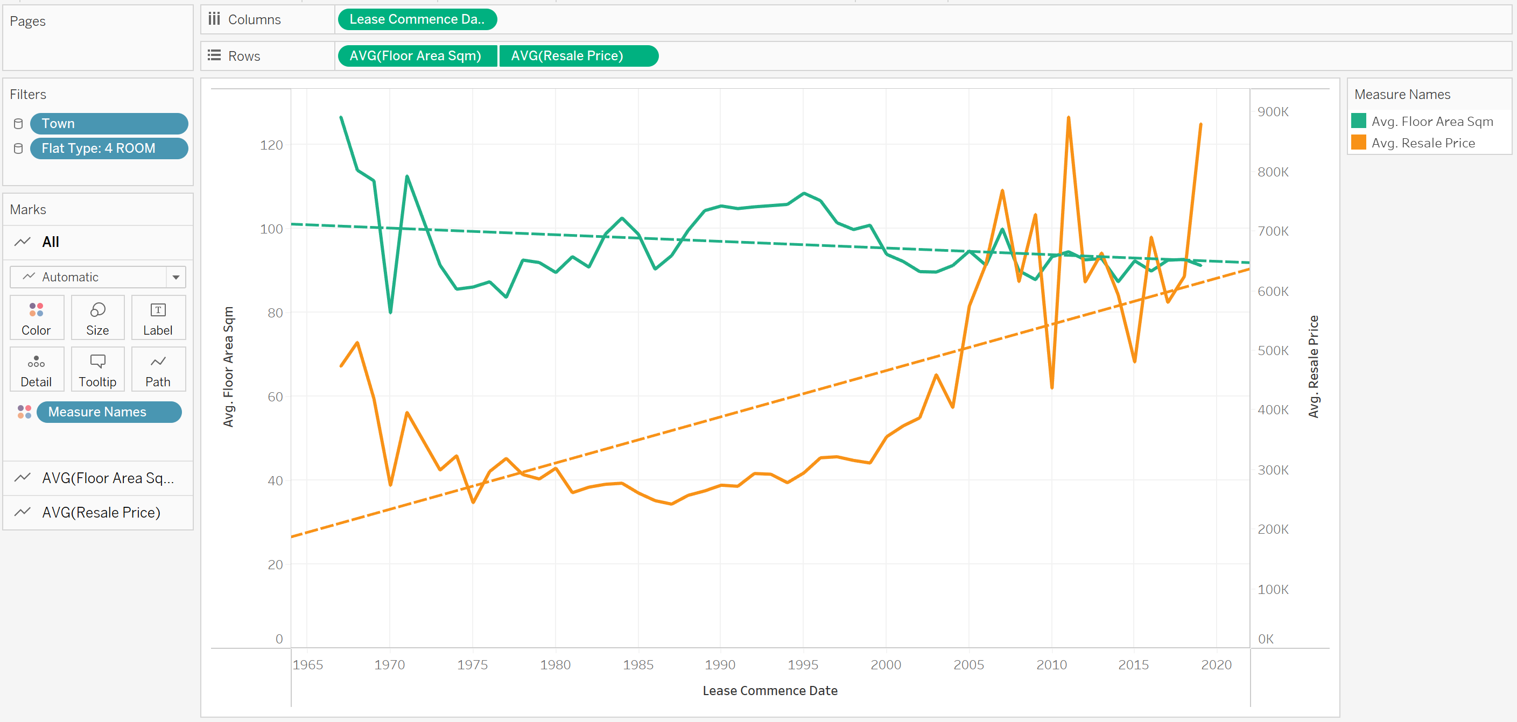

This visual shows the trend of the average floor area sqm and the average resale price over the years and their respective trend lines. The green line represents the average floor area sqm and the orange line represents the average resale price. From this visual, the trend lines show a steady decline in the average floor area sqm and a sharp incline in the resale price. Using this information, the stakeholders should purchase their resale flat as soon as possible as they might have to pay more for a smaller flat if the trend continues.

(The trends of Avg. Floor Area Sqm and Avg. Resale Price for Lease Commence Date. Color shows details about Avg. Floor Area Sqm and Avg. Resale Price. The data is filtered on Town and Flat Type. The Town filter keeps 11 of 27 members. The Flat Type filter keeps 4 ROOM.)

1. What is the average resale price for a 4-room flat in the south and west of Singapore in the different floor ranges?

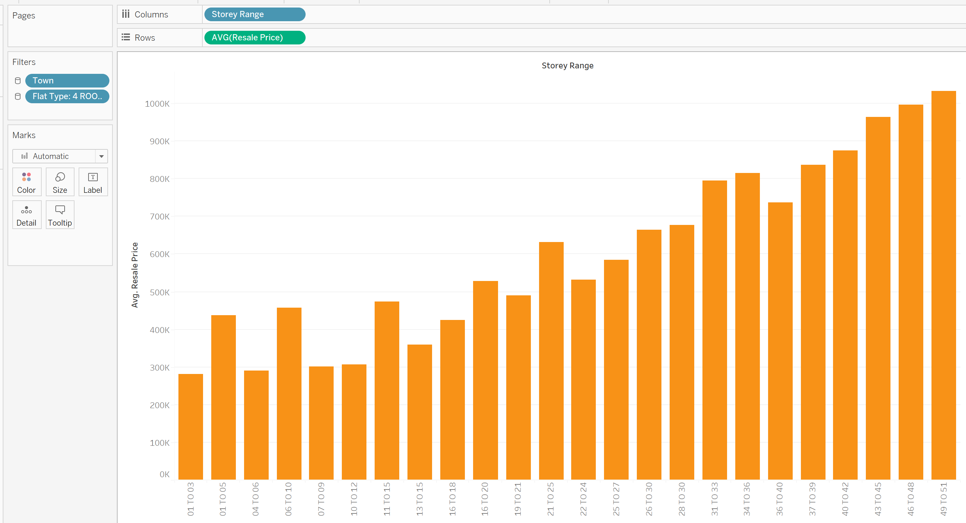

The Visual shows the average resale price of a 4-room flat in the different flat ranges. The visual shows that the floor range 49-51 is the most expensive while floor range 01-03 is the cheapest. From this, the stakeholders can identify the different flat ranges based of their affordability and decide if they wish to purchase a cheaper flat at a lower floor or a pricier flat at a higher floor.

(Average of Resale Price for each Storey Range. The data is filtered on Town and Flat Type. The Town filter keeps 11 of 27 members. The Flat Type filter keeps 4 ROOM.)

1. For a 4-room flat in the south and west of Singapore, what is the relationship between the number of resale price transactions against the flat’s age?

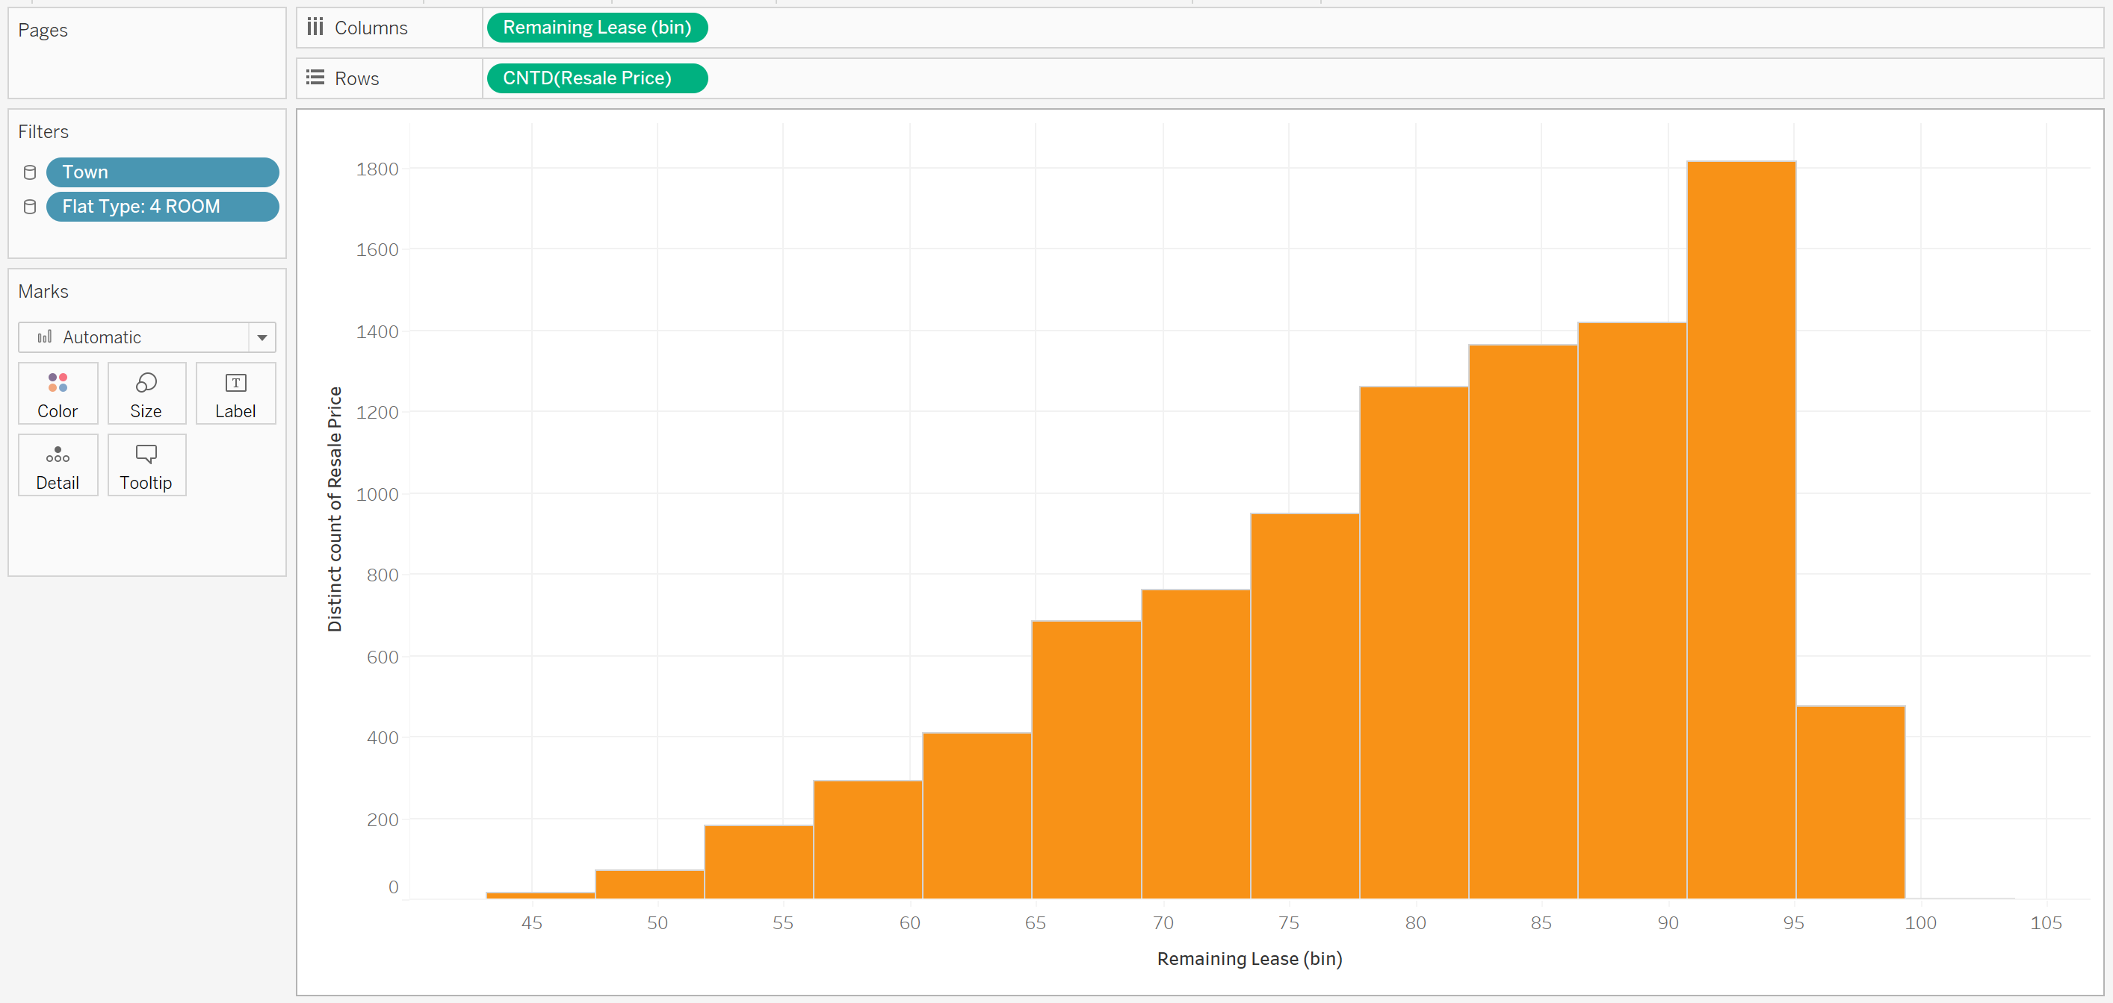

This visual shows the number of resale flat transactions based of the remaining lease of the flat. From this visual, the overall trend shown is that the shorter the lease the lower the number of resale flat transactions. From this, the stakeholders planning to sell their flat in the next 10 to 20 years should consider buying a flat with a longer remaining which has a higher demand in the market.

(The trend of average of Resale Price for Remaining Lease. The marks are labeled by average of Resale Price and Remaining Lease. The data is filtered on Town and Flat Type. The Town filter keeps 11 of 27 members. The Flat Type filter keeps 4 ROOM.)

1. What is the average resale price for a Floor Area Sqm of the different 4-room flat models in the south and west of Singapore?

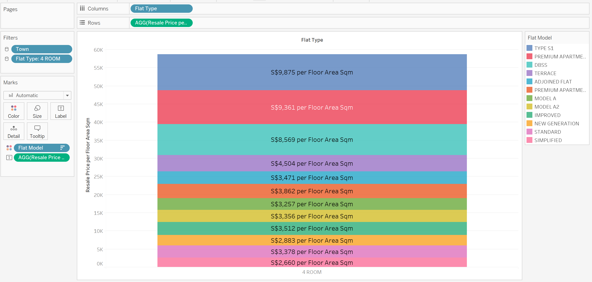

This visual shows the different flat models resale price per Floor Area sqm in descending order of resale price per Floor Area Sqm. From this visual, Flat model “TYPE S1” has the highest resale price per floor area Sqm of $9,875 and Flat model “SIMPLIFIED” has the lowest resale price per floor are Sqm of $2,660. From this, the stakeholders can identify the flat types that fit into their budget and size requirements.

(Resale Price per Floor Area Sqm for each Flat Type. Color shows details about Flat Model. The marks are labeled by Resale Price per Floor Area Sqm. The data is filtered on Town, which keeps 11 of 27 members. The view is filtered on Flat Type, which keeps 4 ROOM.)

# Dashboards

## Dashboard 1

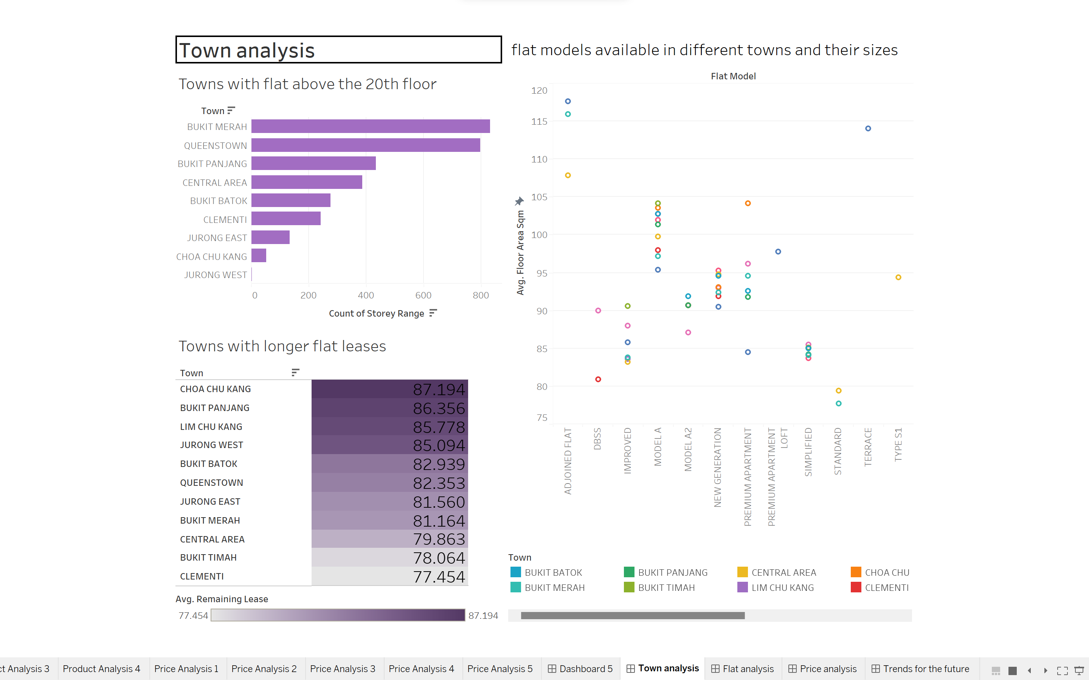

This dashboard shows the analysis of the different elements in deciding which location would be ideal for the stakeholder.

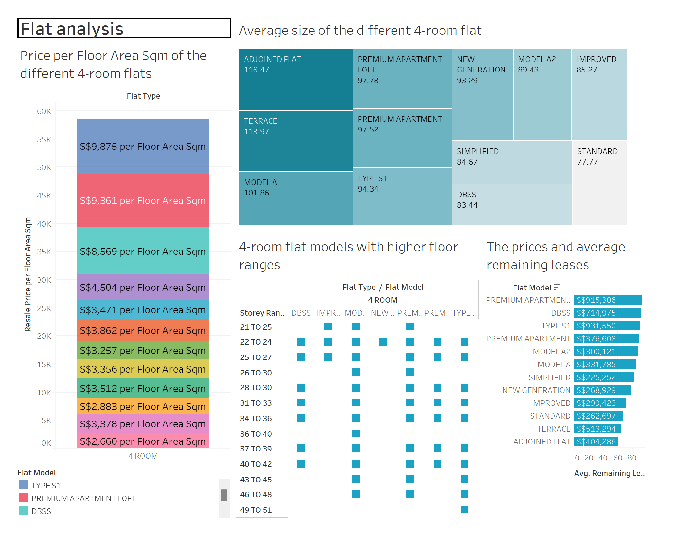

This dashboard shows the different visuals related to the different 4-room flat models. The information provided from this dashboard are the different resale price per floor area sqm, size, price and average lease and the storey range of the different 4-room flat models.

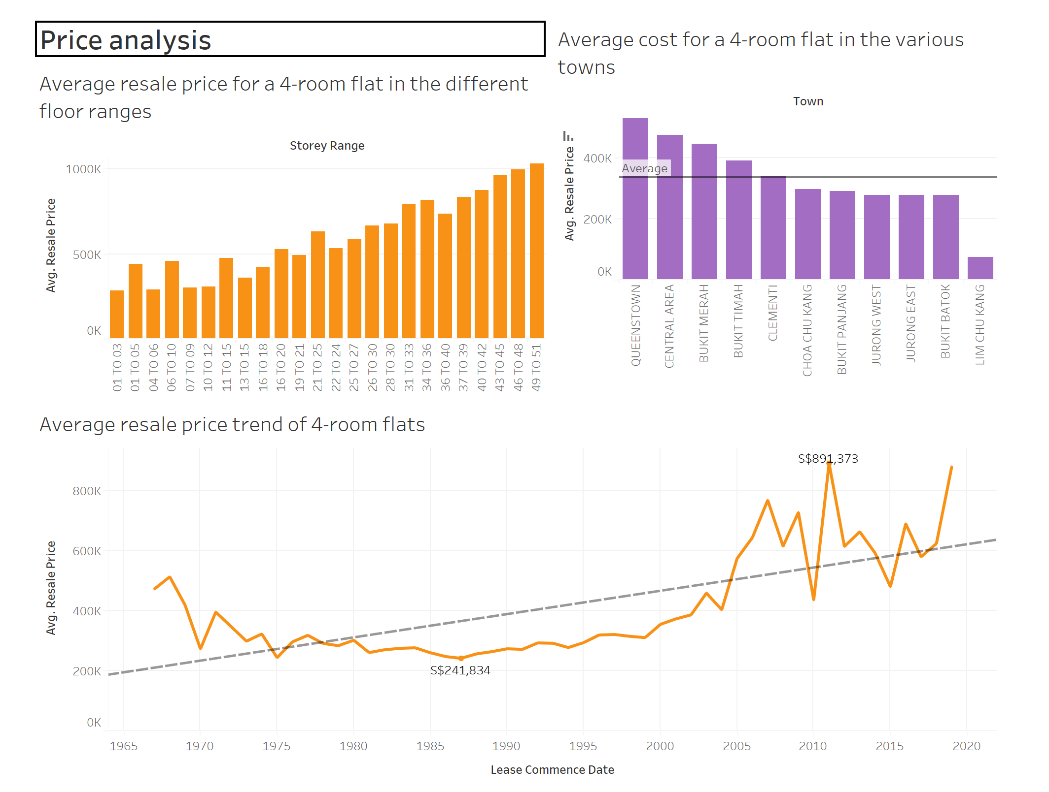

This dashboards show the different visualizations that analysis the resale price of a 4-room flat over the different storey ranges, towns and years.

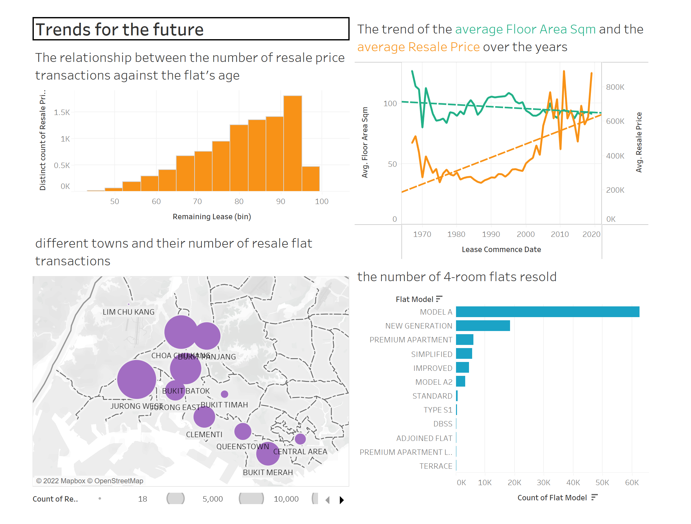

This dashboard shows the visuals that can be used to help predict how to future resale market would be like in the coming years.

# References

*HDB | About Us*. (n.d.). <https://www.hdb.gov.sg/cs/infoweb/about-us>

Poh. (2022, August 25). *Buying a HDB BTO Flat: A Step-By-Step Guide (Aug 2022)*. yahoo.com. <https://sg.finance.yahoo.com/news/buying-hdb-bto-flat-step-020029220.html>

Ho, T. (2022, May 18). *BTO Vs Resale: Which Should You Choose?* DollarsAndSense.sg. <https://dollarsandsense.sg/bto-vs-resale-choose/>

Ng. (2022, November 30). *20-24% of first-time BTO applicants in mature estates successful on first try: Desmond Lee*. The Straits Times. <https://www.straitstimes.com/singapore/politics/20-to-24-of-first-time-bto-applicants-in-mature-estates-successful-on-first-try-desmond-lee>

*HDB | Proximity Housing Grant (Families)*. (n.d.). <https://www.hdb.gov.sg/residential/buying-a-flat/flat-and-grant-eligibility/couples-and-families/proximity-housing-grant-families>